
C. Miles, R. Timothy, P. Kreider, and E. Scheenstra, WSU Mount Vernon NWREC
16650 State Route 536, Mount Vernon, WA 98273

When to Harvest a Melon

In 2019 we grew 10 melon varieties at Washington State University Mount Vernon Northwestern Washington Research and Extension Center (WSU NWREC). Varieties included 5 cantaloupe, 4 honeydew and 1 ananas type. The terms cantaloupe and muskmelon tend to be used interchangeably in the U.S., and here we use the term cantaloupe.

In general, we found that all the melons we trialed reached maturity and produced good quality fruit. See our production report for details.

Melons are climacteric fruit, that is, fruit will ripen after it is picked, altering fruit firmness, color, flavor, aroma and texture. Skin color will also change after fruit has been picked. Melons are picked when fruit ‘slips’ from the vine.

- ½ slip has some cracking at the vine and requires some pressure to snap the stem
- ¾ slip the abscission zone between fruit and stem is 3/4 separated, twist the fruit off the vine
- Full slip is when fruit separates from the pedicel on touch

Information presented for each variety here is based on our experience harvesting these varieties at WSU NWREC in 2019.

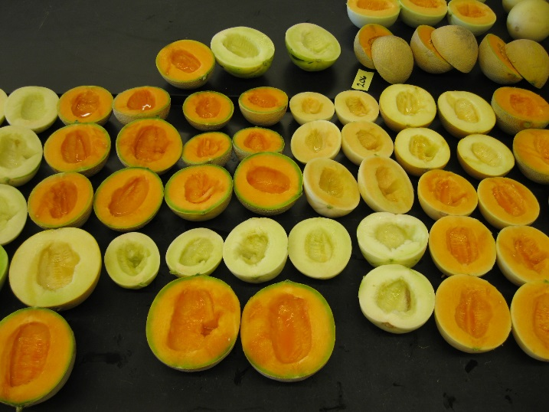
Cantaloupe
Athena (75 d) Fruit skin turns from green (immature) to light green-tan (peak maturity) to orange (over mature). Netting is defined. Fruit did not slip at peak maturity.

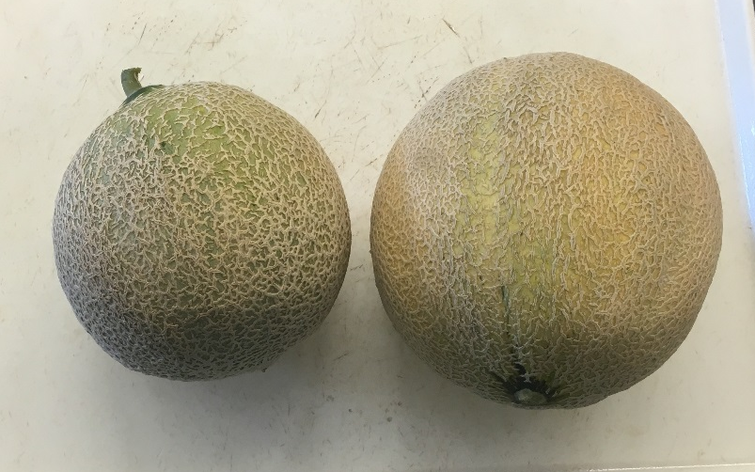

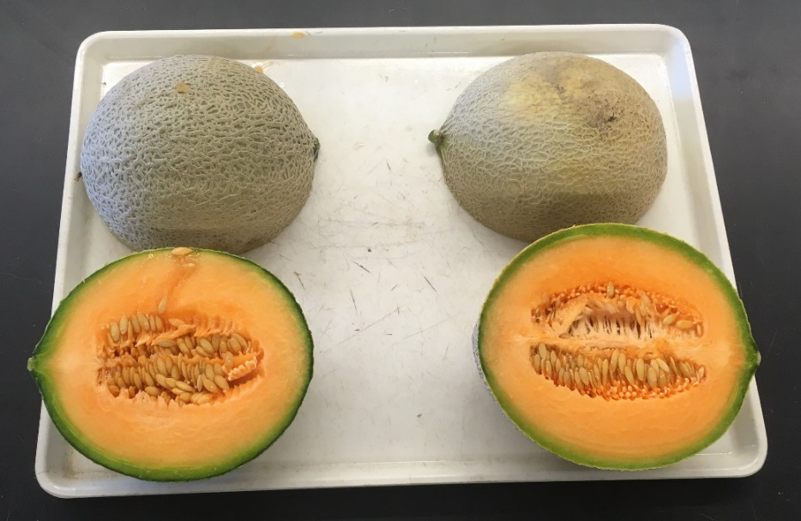
Cantaloupe
Divergent (70 d) Harvest when fruit skin turns light green under defined netting; when skin starts to turn yellow-tan and fruit slips, fruit is over ripe.

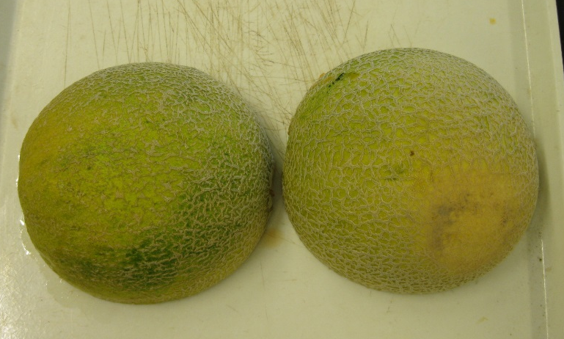

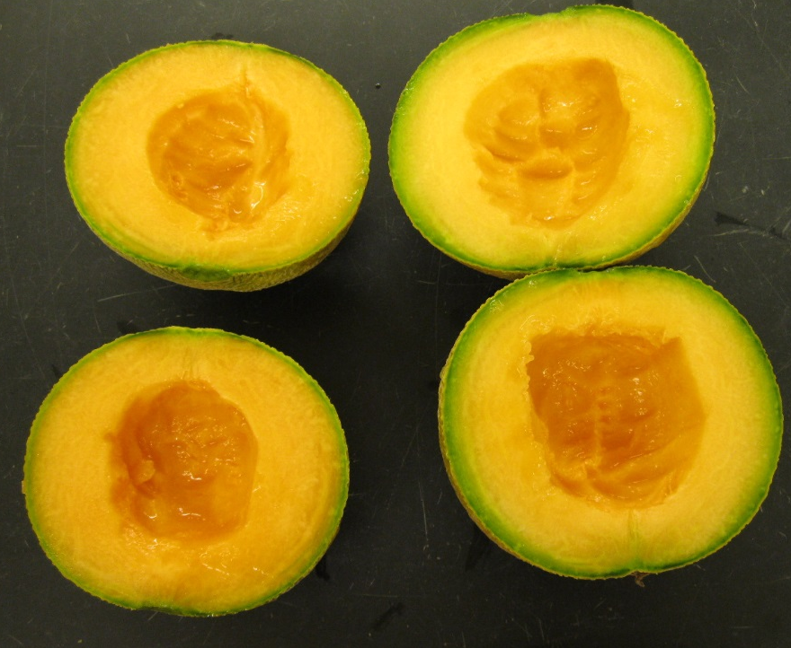

Cantaloupe
Goddess (68 d) Harvest when fruit is tan-beige color on ½ the melon, with defined netting; fruit at ¾ slip for harvest. Orange skin color fruit is over-ripe.

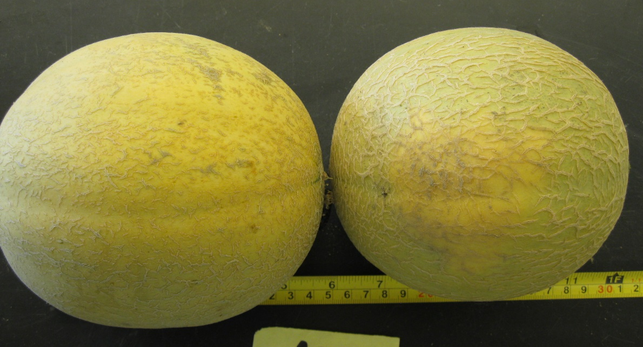

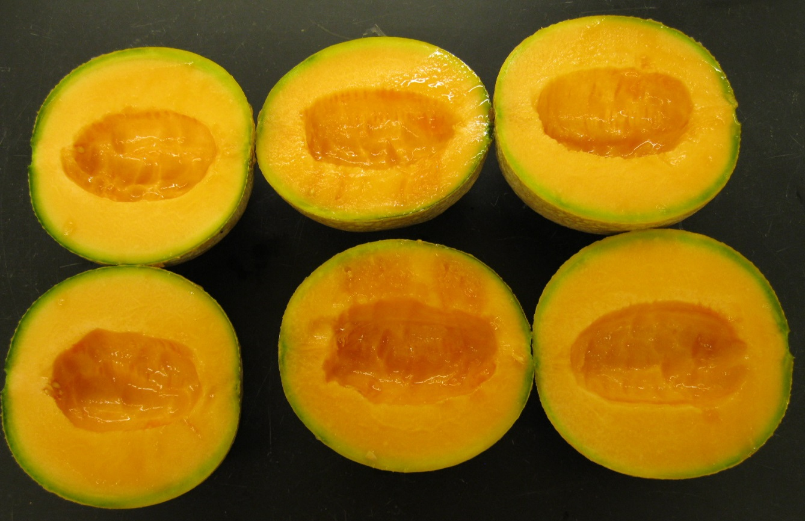

Cantaloupe
Sugar Cube (70 d) Fruit skin color light green to turning orange, fruit will full slip; netting is obvious.

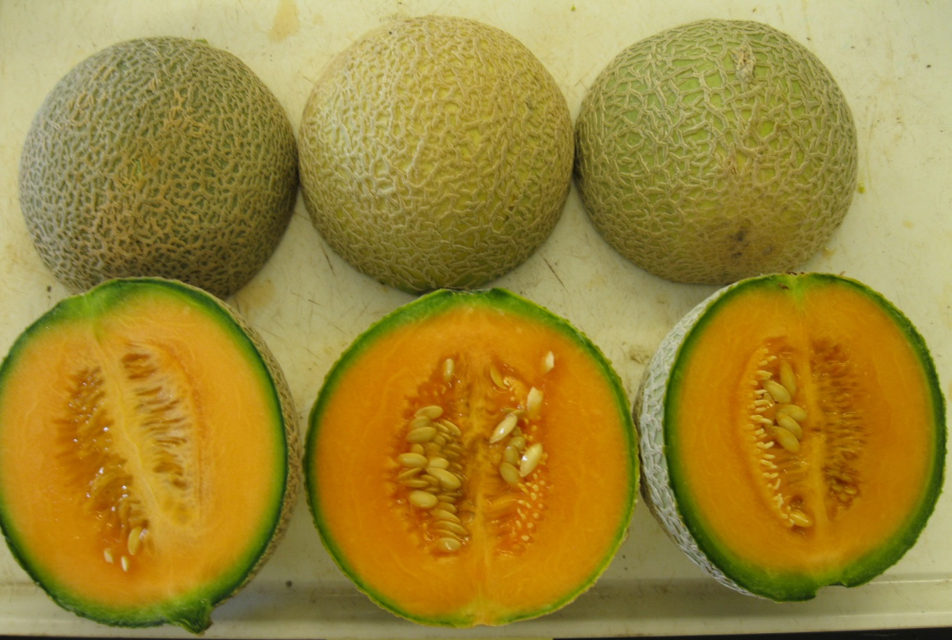

Cantaloupe
Sugar Rush (75 d) Harvest fruit when skin is light green turning tan, with defined netting. Fruit slip easily at full slip and easily separates from stem with a ½ twist when at ¾ slip. When fruit turns golden-orange it is over-ripe.

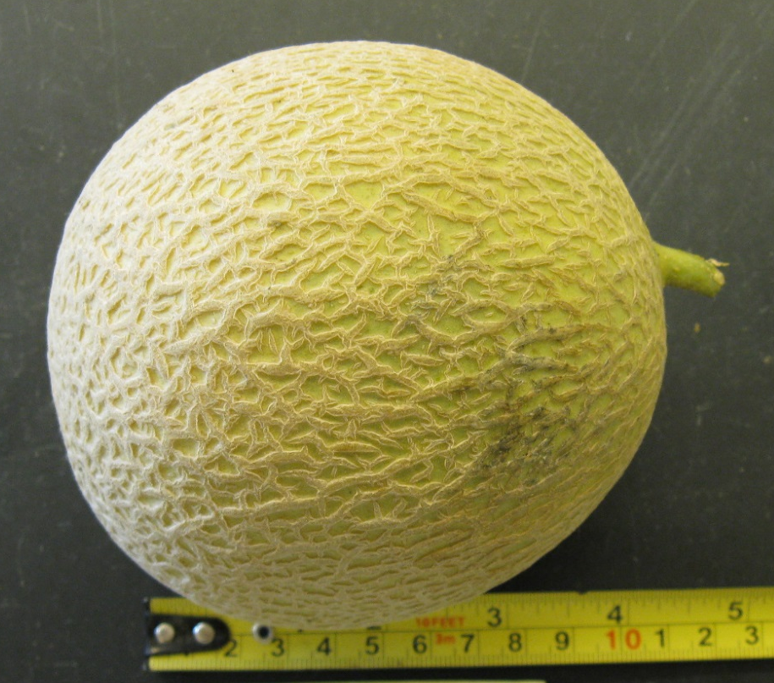

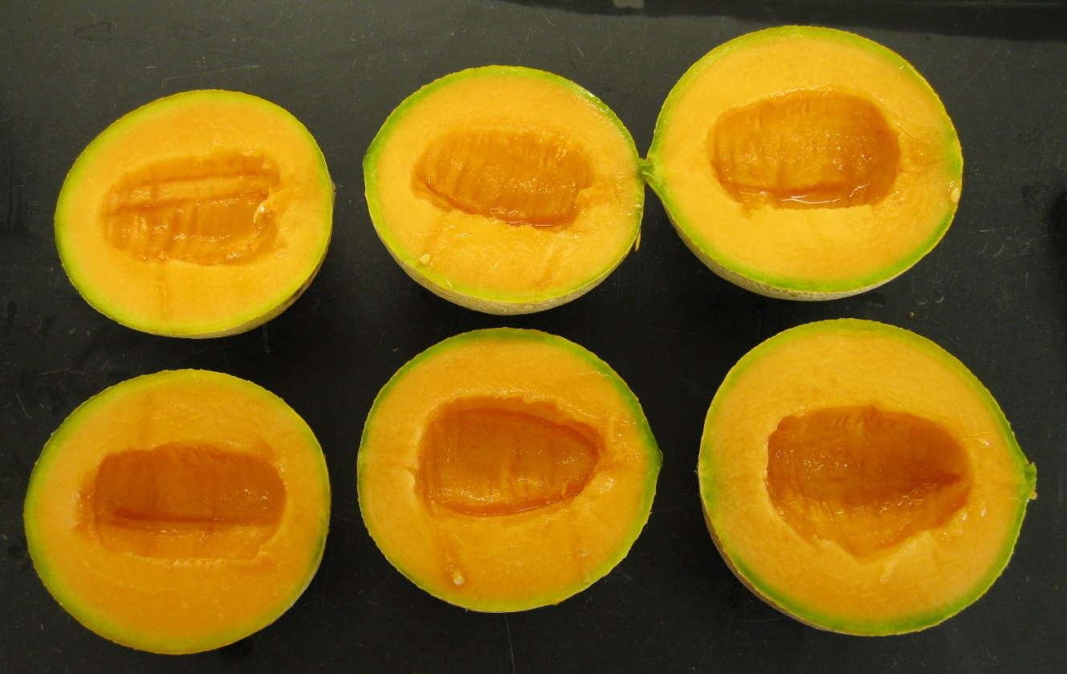

Honeydew
Orange Sugar (70 d) light cream color, blossom end has a yellow color.

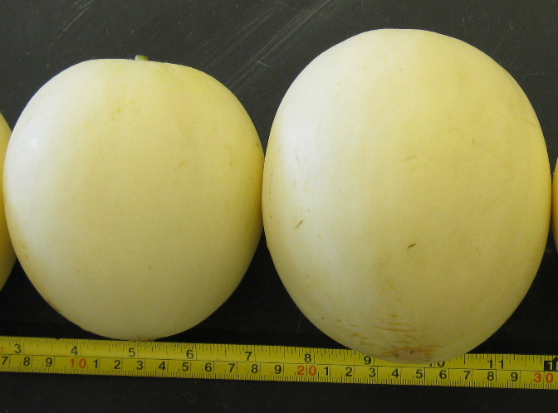

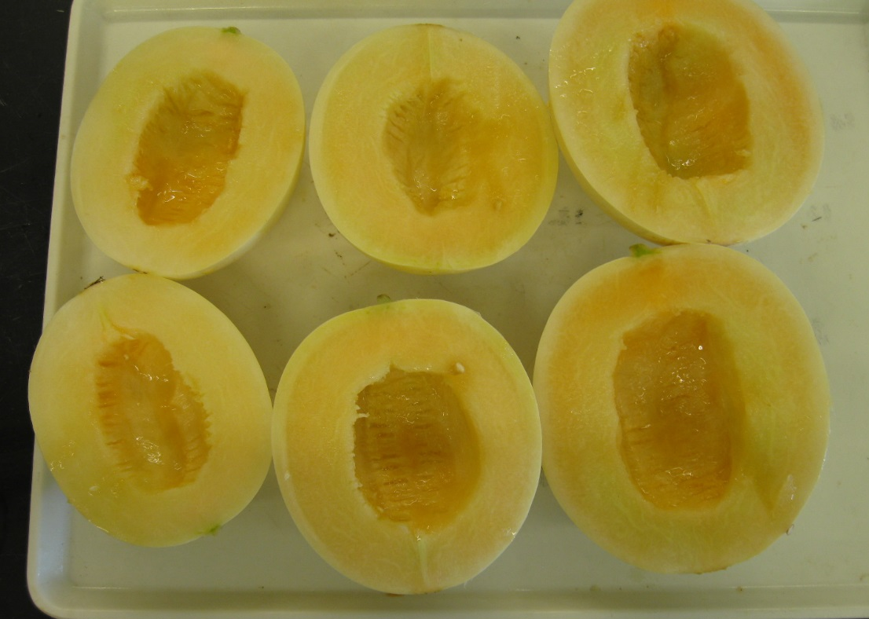

Honeydew
HD93 (80d) Fruit skin color will be cream to white when ready to pick. Full slip and yellowing skin color may be overripe.

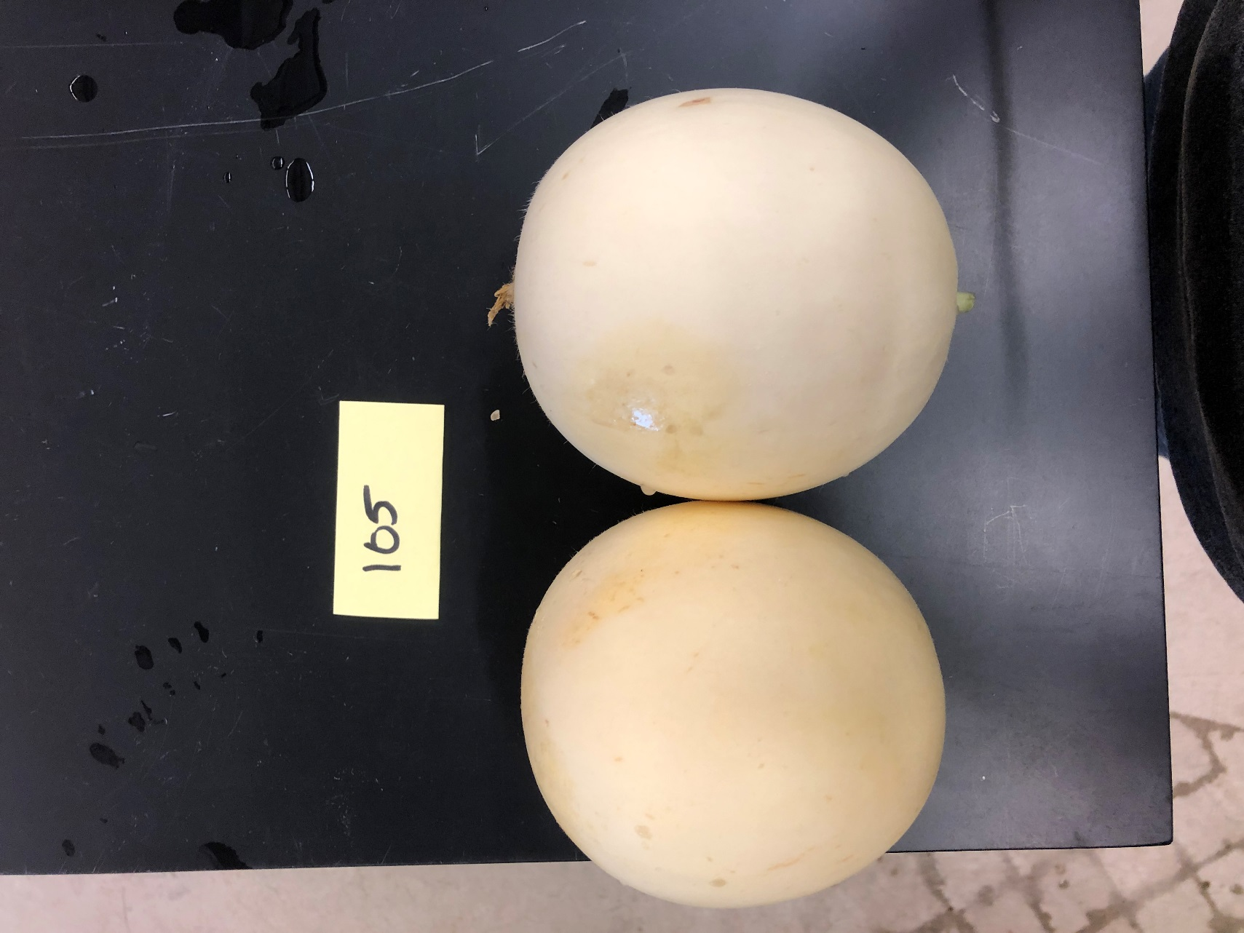

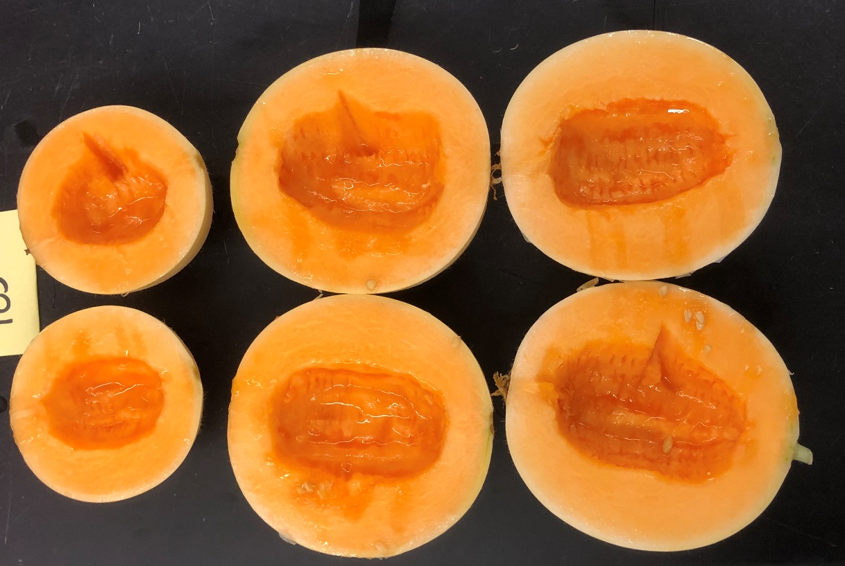

Honeydew
Pongo (75 d) Skin light cream color on bottom half of fruit (side facing down) with remaining half of fruit light green, no slip. Green stripes tend to stand out more against white background as fruit ripens. Stores well at room temperature.

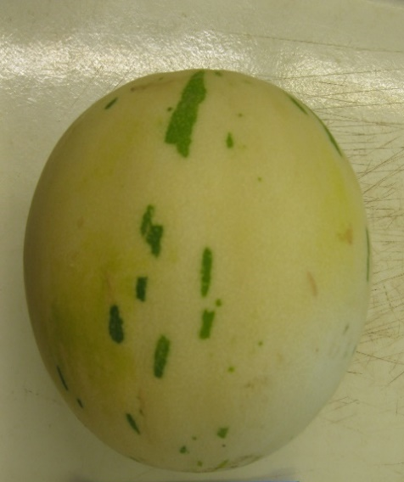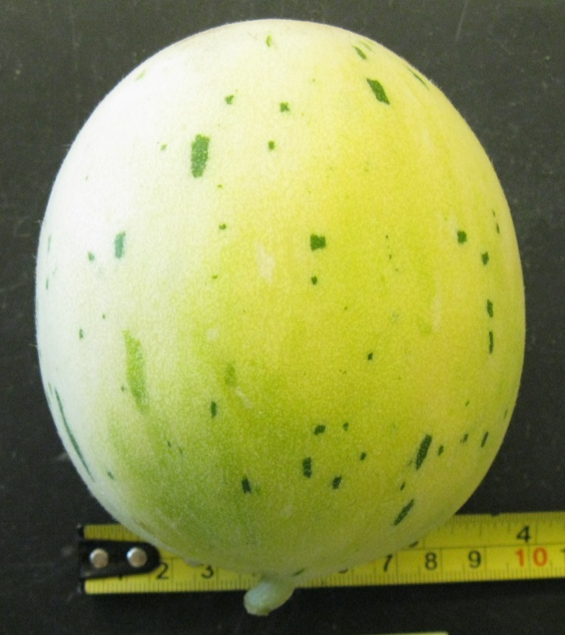

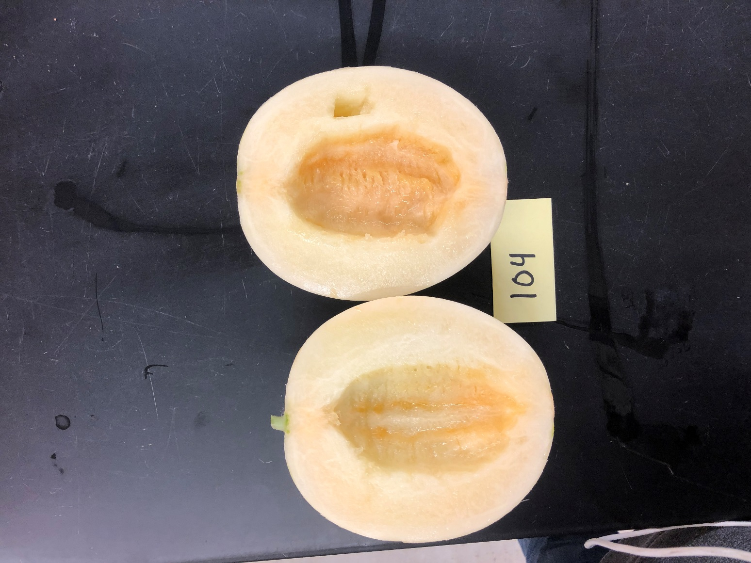

Honeydew
Snow Mass (75-80 d) Fruit skin creamy yellow color, tendril attached to stem at the fruit is dry/brown.

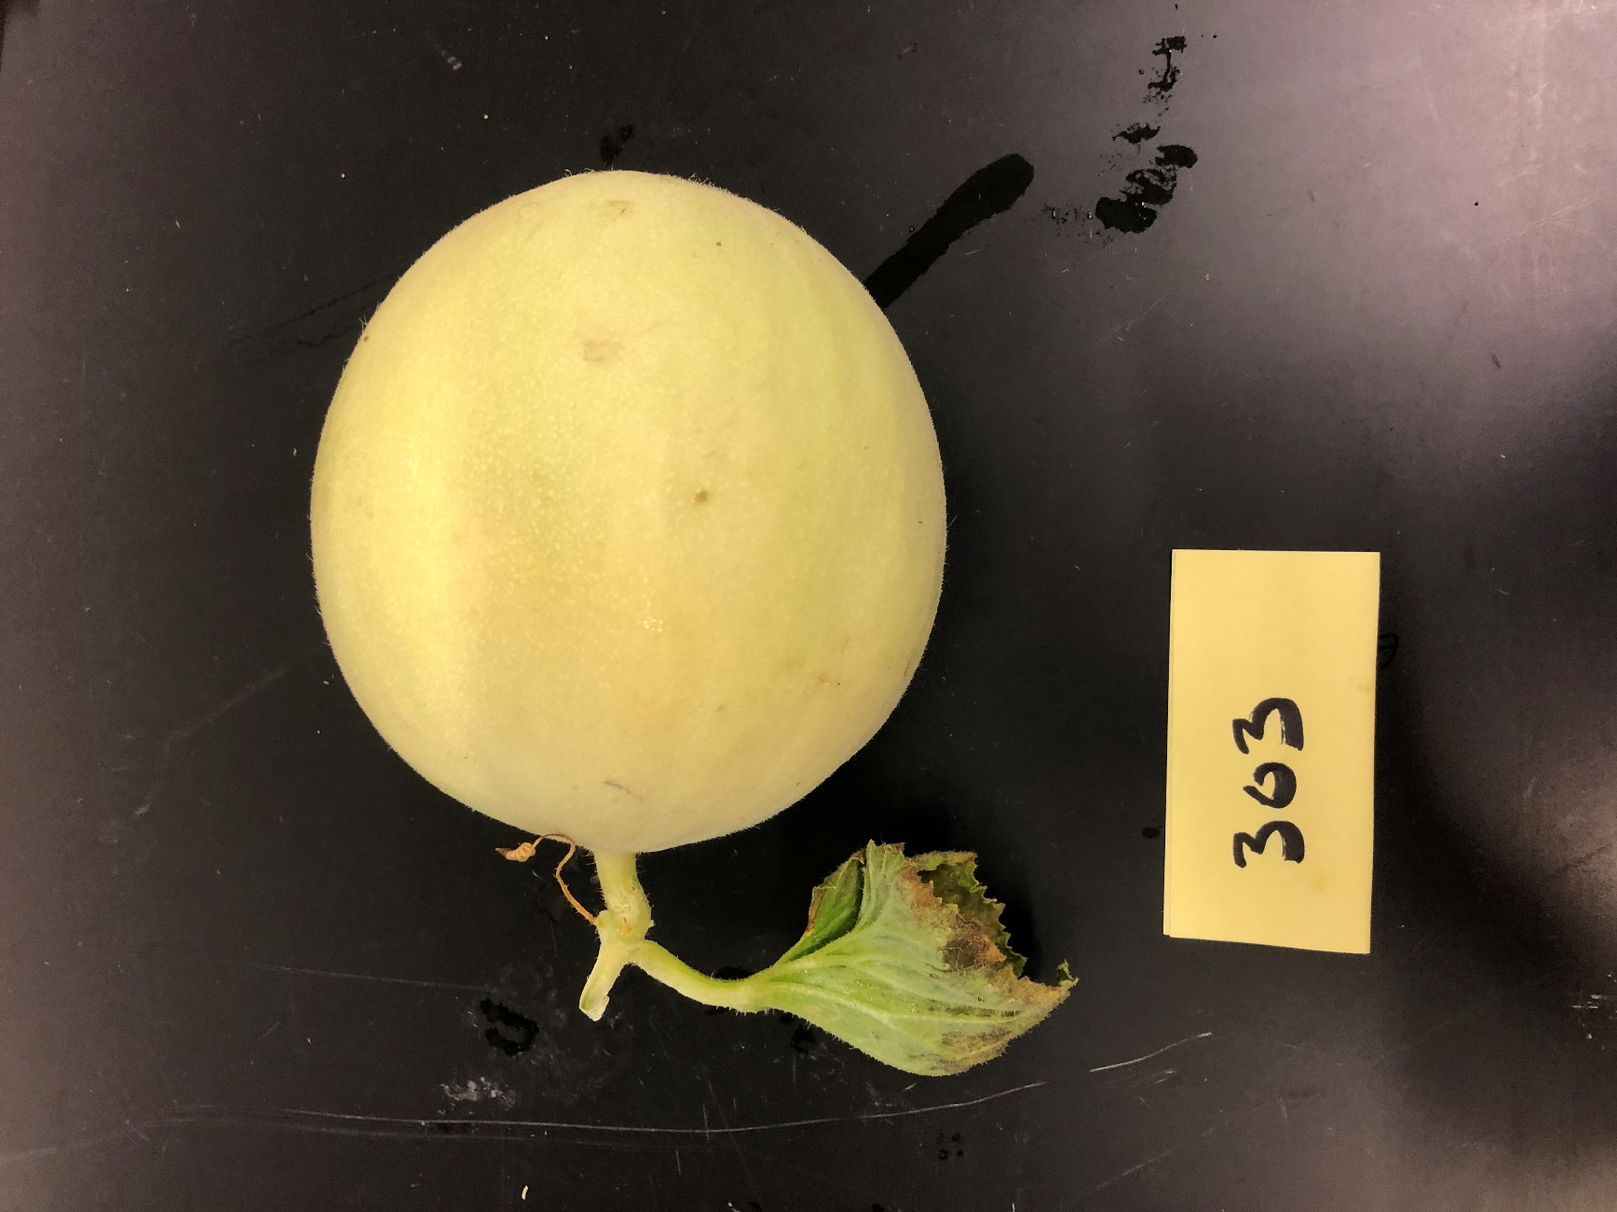
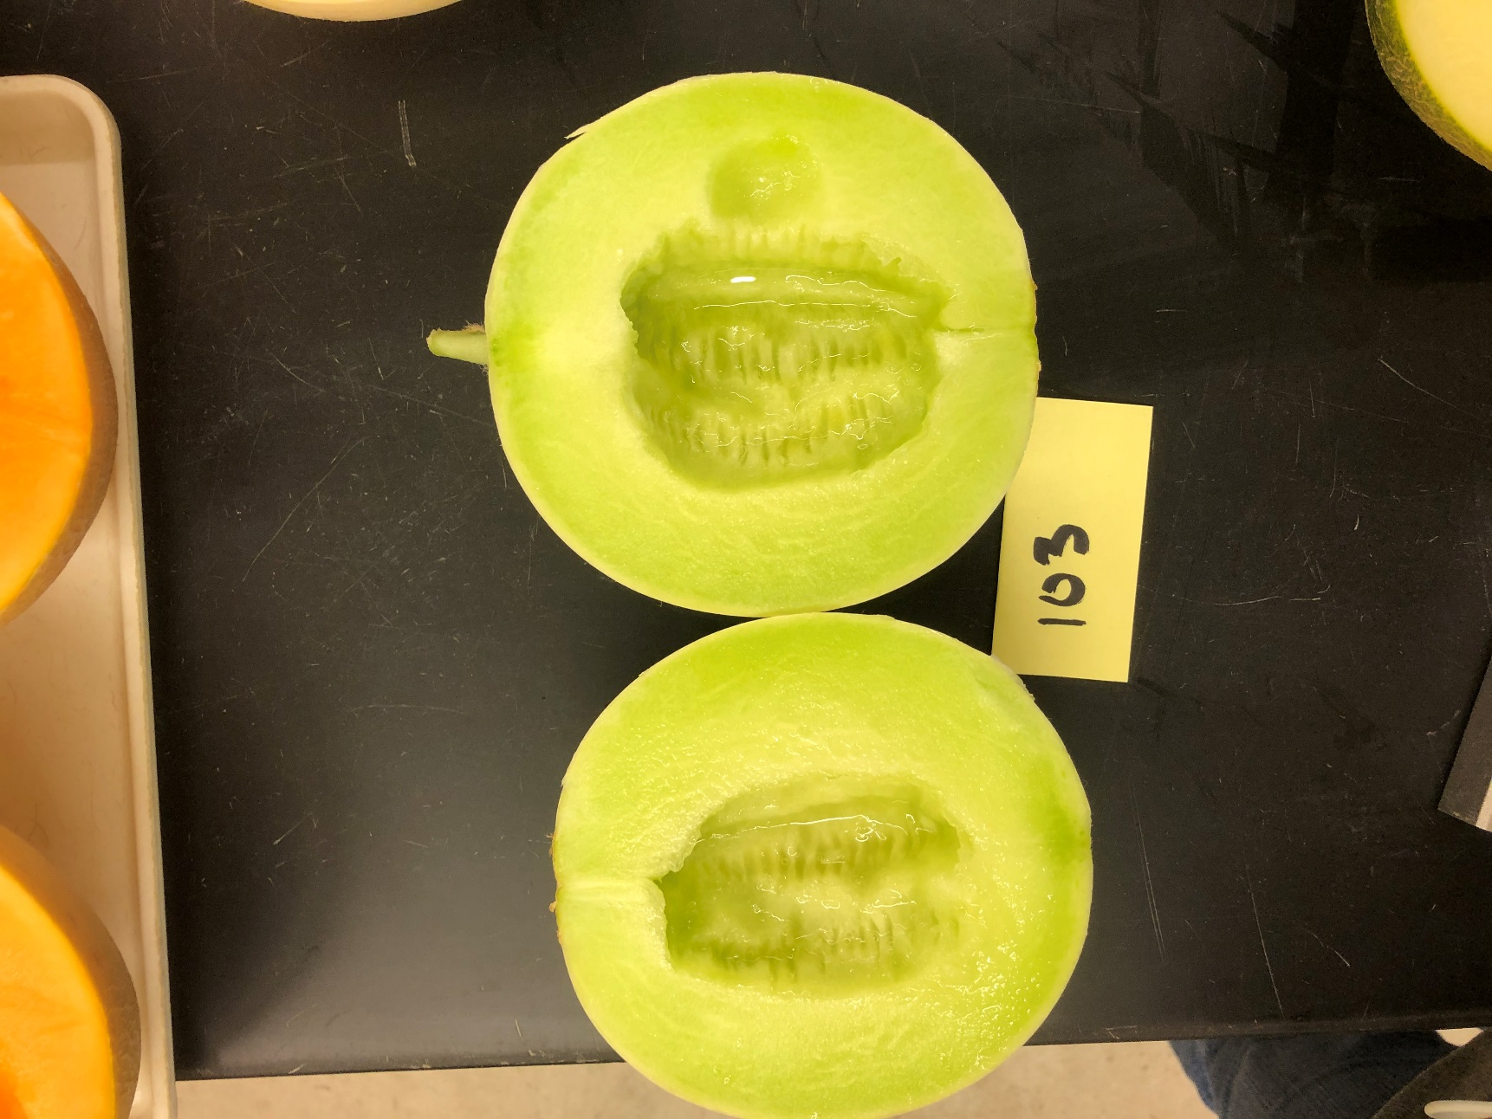

Ananas
San Juan (75 d) Fruit is ready to pick when skin starts turning from green to yellow and with ¾ slip, and netting is defined. Turns orange and has full slip when over-ripe.

