
C. Miles, M. Dolieslager, P. Kreider and E. Scheenstra
WSU Mount Vernon NWREC
16650 State Route 536, Mount Vernon, WA 98273

Melon Variety Trial 2019

The study was carried out at WSU Mount Vernon NWREC in 2019 and included 10 varieties of melon, including 5 cantaloupe, 4 honeydew and 1 ananas. Seed was donated by Osborne Seed Company and Harris Seeds. The 10 varieties were grown in a high tunnel (30’x96’ Semi Gable 5’ On Center, Oregon Valley Greenhouses. Aurora, OR) and the adjacent open field. The experimental design was a randomized complete block with 2 replications and 5 plants per plot. The planting design was a single row with plants spaced 0.9 m (3 feet) apart in-row. In the high tunnel rows were not raised or covered with mulch and were spaced 1.8 m (6 feet) apart. In the open field rows raised beds were formed (2600 Rain-Flo Irrigation, East Earl, PA) and were 15 – 20 cm (6-8 in.) high, 0.8 m (32 in.) wide, covered with black plastic mulch (1 mil thickness; Filmtech, Allentown, PA), and spacing was 3 m (10 ft.) center-to-center (mulch provided weed control while the wide alley width allowed us to cultivate between beds for weed control, which reduced our field plot maintenance costs). Drip tape (T-Tape, Model #508-08-340, 8 in. emitter spacing, 0.34 GPM flowrate; John Deere, San Diego, CA) was installed on the center of the beds, and in the open field was placed under the mulch at the same time beds were formed.

Seeding and transplanting: On 29 April, 36 seeds of each variety were planted in organic seeding mixture (Sunshine N&O #3, Sungro, Agawam, MA) in a greenhouse, except Sugar Rush, which was seeded on 2 May due to late seed arrival. On 28 May, melons were transplanted into the high tunnel and the adjacent open field (Fig. 1).

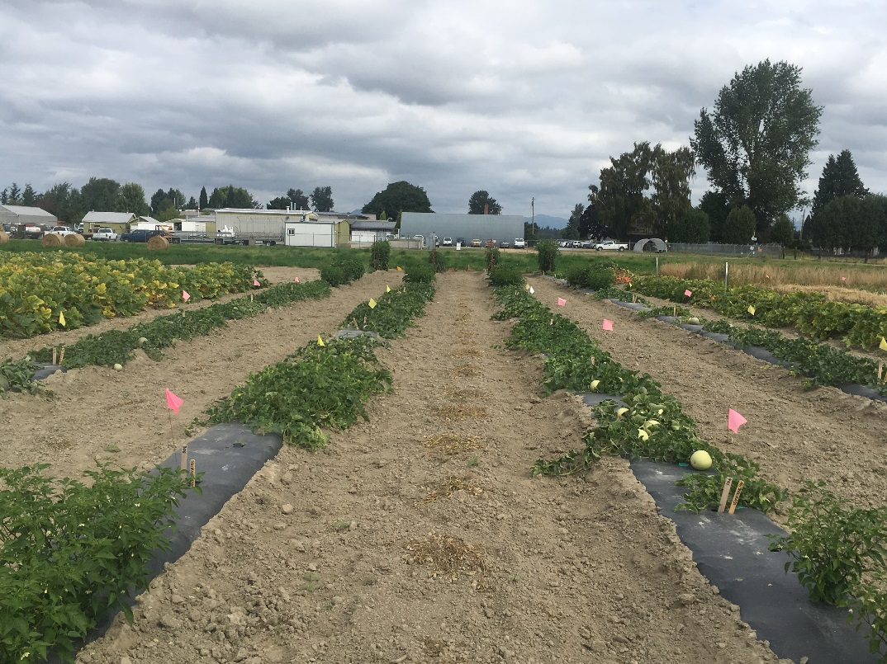
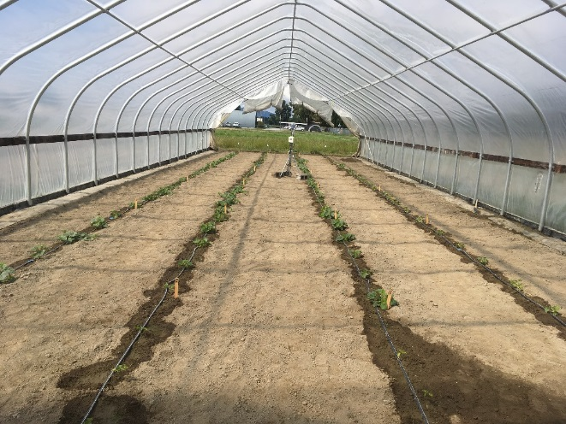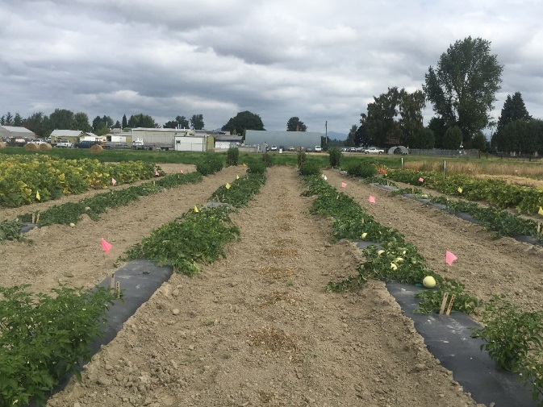
Aug 19
Figure 1. Melons in the high tunnel on June 27 and in the adjacent open field on August 19.

Fertilizer and irrigation: Triple 16 fertilizer (Wilbur-Elis Co, San Francisco, CA) was applied to the center of all rows at the rate of 100 lb N/A. Fertilizer was applied to the field portion of the trial with a 6ft drop-spreader (Gandy, Owatonna, MN). The field rows were then mulched with black 1M polyethylene mulch (Filmtec, Bean Station, TN). In the high tunnel, fertilizer was hand raked into rows whereas in the open field fertilizer was incorporated into the raised bed by bed shaping.

Irrigation was installed May 9 and ran for one hour. Two days prior to transplanting melon seedlings and immediately after transplanting, all rows were irrigated for 1.5 hours. Thereafter, all rows were irrigated once a week for 3 hours.

Results
Fruit yield and quality: Number of days from transplanting to first harvest were recorded and compared to information obtained in an experiment in 2018 at the same location and to information provided by seed companies. Days to first harvest are 68–80 days according to seed companies and 75–85 days after transplanting based on our 2018 field study at this location. In 2019, days to first harvest in our study were 92–105 in the field and 90–98 in the high tunnel, and the average was 98 days in the field and 94 days in the high tunnel.

Melons were assessed for maturity twice per week starting 60 days after transplanting, and fruit were harvested at ¾ to full slip for cantaloupe, and when fruit turned the appropriate color as tested through our preliminary harvests. Total weight and number of all harvested fruit per plot were recorded at each harvest, and average fruit weight was calculated. Three representative fruit per plot were randomly selected at peak harvest and fruit length and diameter were recorded and total soluble solids (TSS, measured as Brix %) was measured (Palm Abbe digital refractometer Model # PA201).

Total fruit weight and number per plant were generally two times greater for all varieties in the high tunnel than in the open field (Figs. 2 and 3). Pongo had the greatest cumulative fruit weight in both the high tunnel and open field, Sugar Cube, a mini fruit variety, had the lowest cumulative fruit weight in the high tunnel and moderate fruit weight in the open field, and Orange Sugar and HD93 had moderate cumulative fruit weight in the high tunnel but were low in the open field. Weight per fruit ranged from 0.5–1.3 kg (1.1–2.9 lb) in the high tunnel and 0.2–1 kg (0.4–2.2 lb) in the open field (Table 2). Fruit tended to be slightly larger in the high tunnel and overall average was 1 kg (2.1 lb) per fruit compared to 0.7 kg (1.7 lb) per fruit in the open field.

The average length of fruit was 12.5 cm (range 9.1–14.7 cm) in the high tunnel and 11.3 cm (range 9.2–13.4 cm) in the open field, while the average width of fruit was 11.9 cm (range 9.6–13.7 cm) in the high tunnel and 8.1 cm (range 9.9–12.7 cm) in the open field. Athena had the largest fruit in the high tunnel. Sugar Cube and Orange Sugar had the smallest fruit in both the high tunnel and the open field. TSS ranged from 9.4–15.3 in the high tunnel and 8.2–12.9 in the open field (Table 2). Fruit tended to be sweeter in the high tunnel and overall average was 12.4% compared to 10.6% in the open field. Sugar Rush (14.1% on average) had the highest TSS while Athena (9.1% on average) had the lowest in both the high tunnel and the open field.

Table 1. Melon varieties grown at WSU Mount Vernon NWREC in 2019 and days to first harvest in a high tunnel (HT) and the open field.

 |  |  |  | Days to Harvest (DAT)¹
 |  |  |  |  | Open field |  | HT
Variety | Type | Source | Seed² | Listed | 2018 | 2019 | 2019
Athena | cantaloupe | Osborne | UT | 75 | 85 | 101 | 96
Divergent | cantaloupe | Osborne | O | 70 | 81 | 96 | 93
Goddess | cantaloupe | Osborne | UT | 68 | 75 | 92 | 91
HD93 | honeydew | Osborne | UT | 75 | -³ | 101 | 95
Orange Sugar | honeydew | Osborne | UT | 70 | 81 | 105 | 95
Pongo | honeydew | Osborne | UT | 75 | - | 100 | 93
San Juan | ananas | Osborne | UT | 75-78 | - | 105 | 96
Snow Mass | honeydew | Osborne | UT | 75-80 | 78 | 93 | 92
Sugar Cube | cantaloupe | Osborne | UT | 70 | 81 | 97 | 98
Sugar Rush | cantaloupe | Harris Seeds | T | 75 | - | 92 | 90
¹ O = organic, UT = untreated, T = treated with a fungicide
² 2018 and 2019 days to harvest were at WSU Mount Vernon NWREC, and were based on days after transplanting
³ Variety was not grown at NWREC in 2018

Table 2. Melon sweetness (% Brix) and fruit size (kg/fruit) grown in a high tunnel (HT) and the open field (OF).
 | Mean Brix (%) |  |  |  | Fruit Weight (kg/fruit)
Variety | HT |  | OF |  | HT |  | OF
Athena | 9.4 |  | 8.8 |  | 1.1 |  | 0.9
Divergent | 12.7 |  | 11.3 |  | 1.1 |  | 1.0
Goddess | 10.4 |  | 11.8 |  | 1.3 |  | 0.8
HD93 | 11.8 |  | 8.6 |  | 0.9 |  | 0.7
Orange Sugar | 13.9 |  | 8.2 |  | 0.6 |  | 0.2
Pongo | 13.3 |  | 12.6 |  | 0.8 |  | 0.8
San Juan | 11.8 |  | 10.0 |  | 1.3 |  | 0.9
Snow Mass | 13.1 |  | 9.0 |  | 1.0 |  | 1.0
Sugar Cube | 12.0 |  | 12.5 |  | 0.5 |  | 0.5
Sugar Rush | 15.3 |  | 12.9 |  | 0.9 |  | 0.5

Table 3. Length and width (cm) of fruits grown in a high tunnel (HT) and the open field (OF).

 | Length per fruit (cm) |  |  |  | Width per fruit (cm)
Variety | HT |  | OF |  | HT |  | OF
Athena | 14.7 |  | 12.1 |  | 13.7 |  | 11.4
Divergent | 12.8 |  | 11.5 |  | 13.7 |  | 12.4
Goddess | 14.4 |  | 13.4 |  | 12.9 |  | 12.1
HD93 | 11.4 |  | 10.9 |  | 11.3 |  | 10.3
Orange Sugar | 11.2 |  | 9.8 |  | 9.6 |  | 8.1
Pongo | 12.5 |  | 11.2 |  | 11.3 |  | 9.6
San Juan | 13.9 |  | 11.6 |  | 13.4 |  | 10.8
Snow Mass | 13.0 |  | 12.6 |  | 12.1 |  | 12.7
Sugar Cube | 9.1 |  | 9.2 |  | 9.7 |  | 9.9
Sugar Rush | 12.2 |  | 10.5 |  | 11.3 |  | 10.6

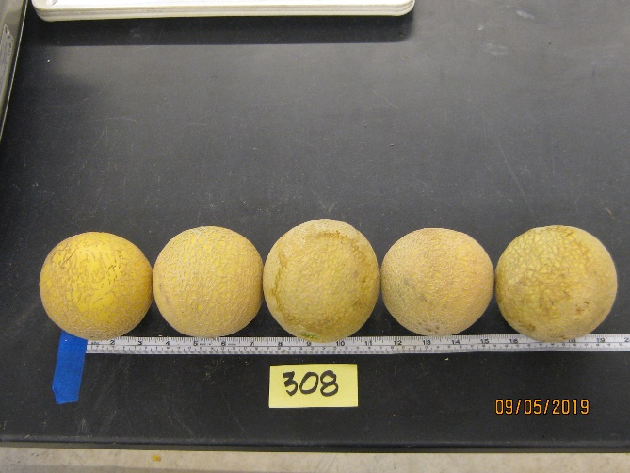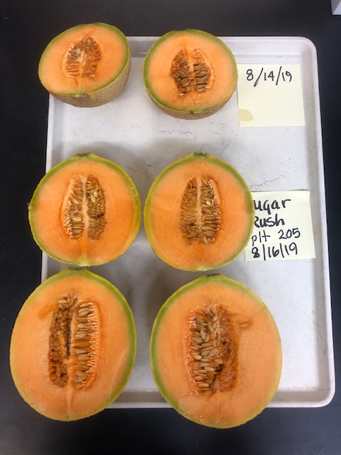

Figure 1: Fruit quality measurements

Figure 2. Fruit weight per plant of melon cultivars grown in high tunnel and open field.

Figure 3. Number of fruit per plant of melon cultivars grown in high tunnel and open field.

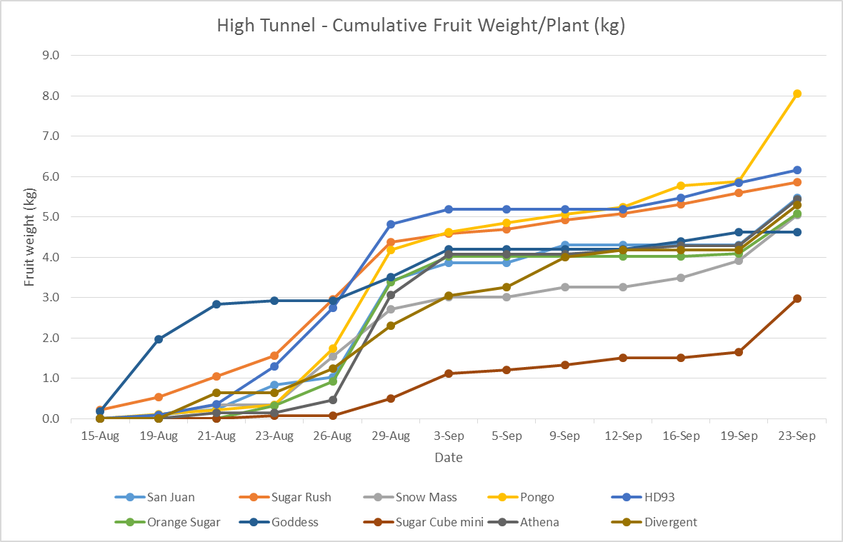
High Tunnel
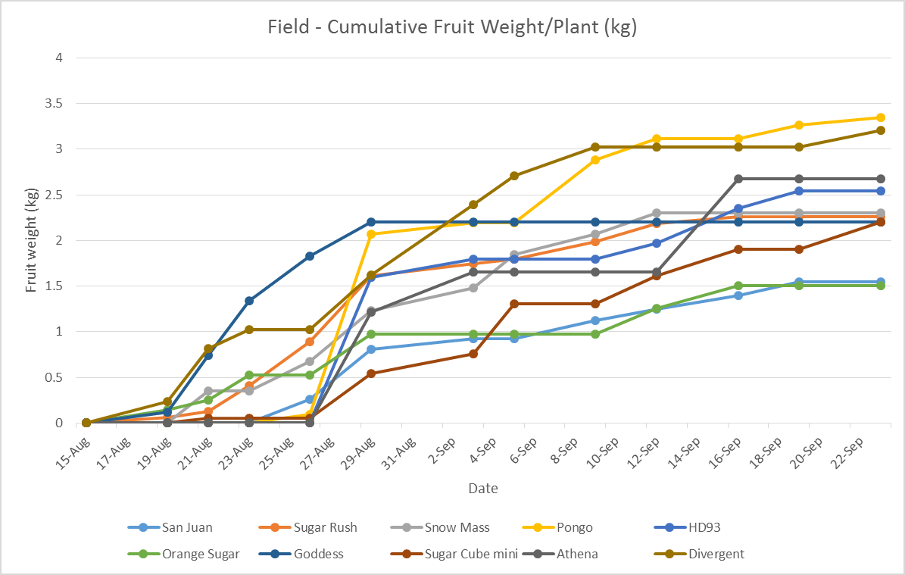
Open Field
Figure 4. Cumulative fruit weight per plant of melon cultivars grown in the high tunnel and open field.
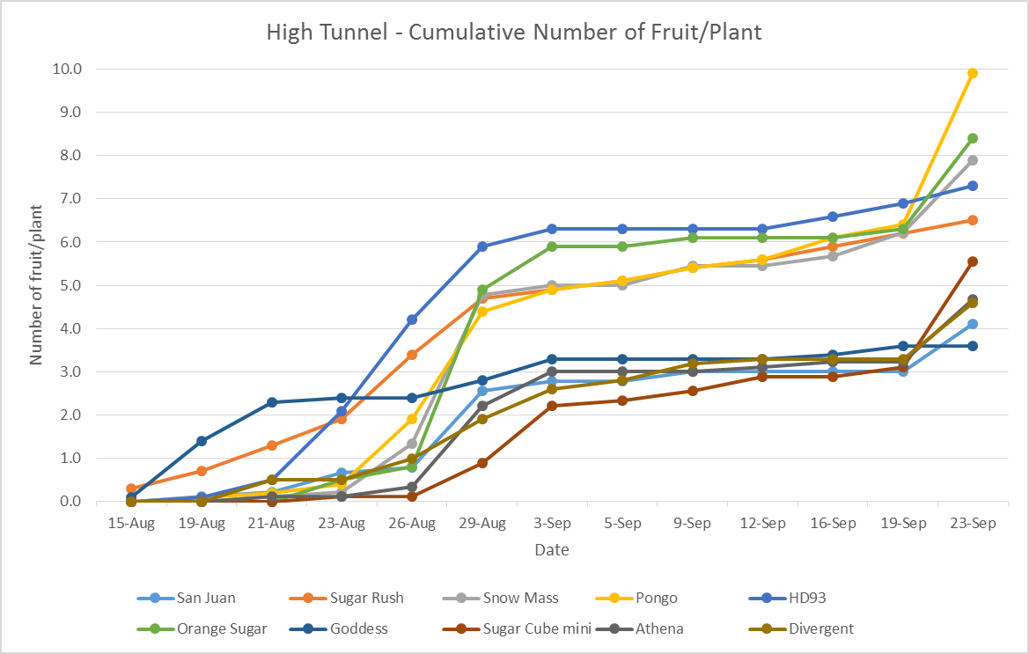
High Tunnel
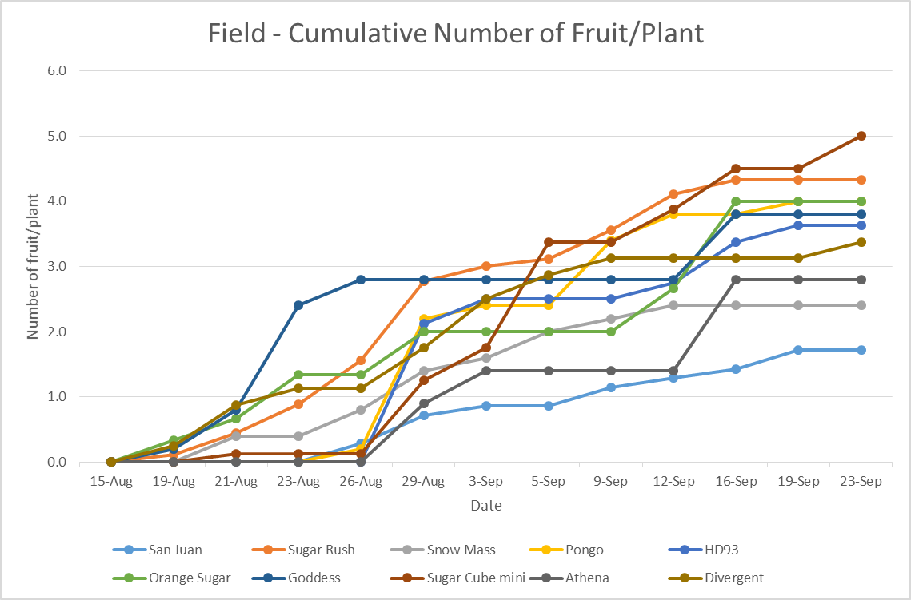
Open Field
Figure 5. Cumulative fruit number per plant of melon cultivars grown in the high tunnel and open field.

