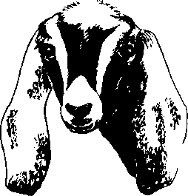
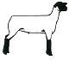
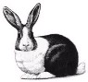

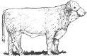


KLICKITAT COUNTY 4-H BREEDING/PET
ANIMAL PROJECT RECORD

Program: Project:
Years in this project:

PROJECT COMMITMENT
This is what I want to learn this year:
Read and Reviewed:
Leader:
Parent:

PROJECT PHOTOS

PROJECT JOURNAL
Date | Time spent | What did you do? | What did you learn?

3
PROJECT JOURNAL

Date | Time spent | What did you do? | What did you learn?
Total Hours
4

ANIMAL PROJECT INVENTORY

Project:

DESCRIBE EQUIPMENT NEEDED FOR PROJECT:

DESCRIBE ANIMAL(S) NEEDED FOR PROJECT:

5

ANIMAL PROJECT EXPENSES

Project: Page of Fill in costs that apply to your project.

Date | Description | Animal | Vet | Equipment & Other | Pasture Rent | Hay/Feed | Grain Cost | Total Cost
INCOME TOTALS |  | $ | $ | $ | $ | $ | $ | $
6

ANIMAL PROJECT INCOME

Project:

Date | Description | Animal Income | Show Premiums | Other | Total Income
INCOME TOTALS |  | $ | $ | $ | $
7

ESSAY QUESTIONS
JUNIOR LEVEL QUESTIONS (To be completed by ALL 4-Hers)
- How did you select your project animal (What were you looking for)?

- Describe how you housed your project animal?

- How did you decide what and how much to feed your project animal?

- What were the biggest challenges with your project and how did you overcome them?

INTERMEDIATE LEVEL QUESTIONS (to be completed by all Intermediates and Seniors in addition to Junior Questions)
- How did you keep your animal healthy and happy?

- Why are record books, educational posters/presentations, herdsmanship, etc. important for your project?

SENIOR LEVEL QUESTIONS (To be completed by all Seniors in addition to Junior and Intermediate questions)
- What would you change about your project?

- What might you look for in a good show animal that would be different than a good commercial animal?

- What are the biggest challenges you see facing your project’s industry?

