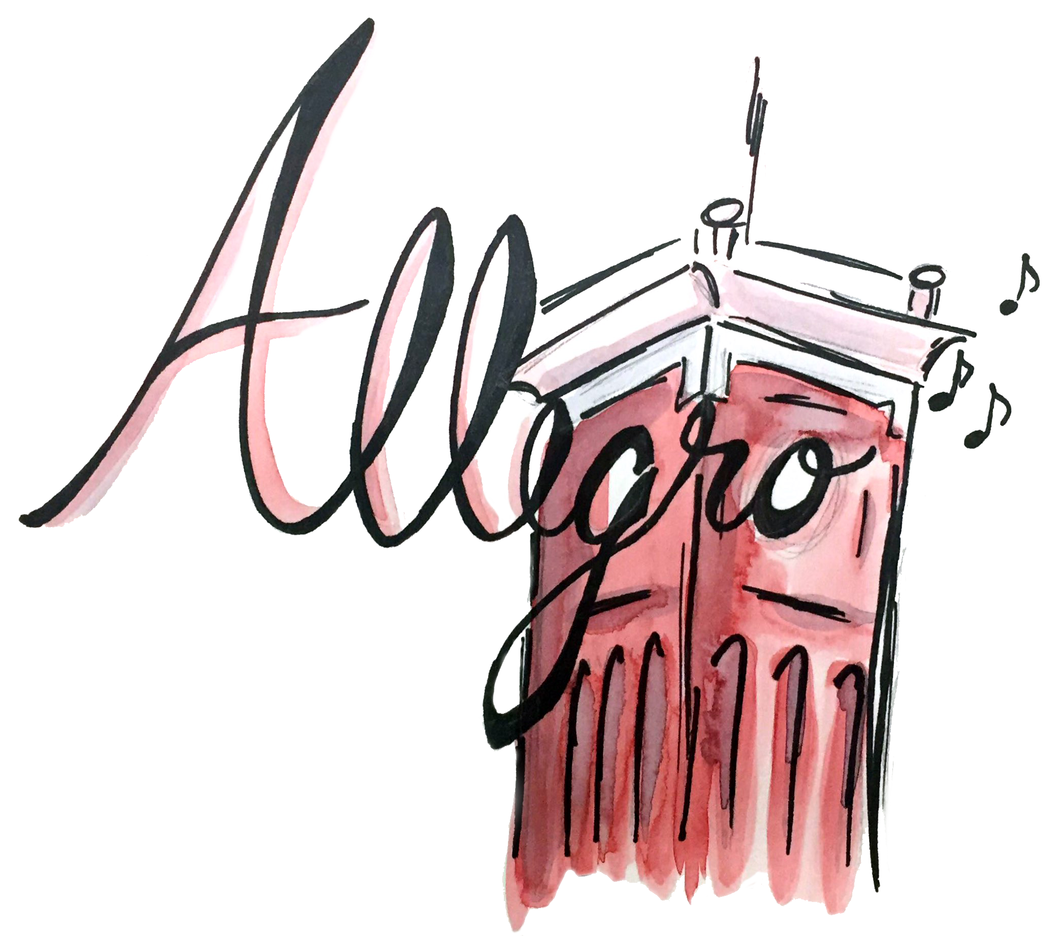
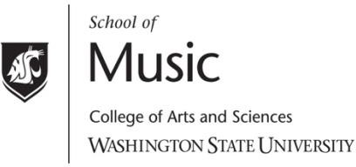

What is Allegro?

Allegro is an umbrella Registered Student Organization that represents all music student organizations at Washington State University. We aim to excite and inspire all students on the WSU campus with and through music. By partnering with student organizations, we provide funding to bring world-renowned guest artists to perform and work one-on-one with WSU students. In addition, Allegro offers travel scholarships to exceptional students and organizations traveling to competitions, festivals, conferences, and other music-related activities. Allegro receives generous funding from the Associated Students of Washington State University.
All RSOs are welcome to apply for Allegro funding. Applications are available in the Kimbrough Music Building office.

Allegro Concert Series

presents

YouTube: Live on Stage

Scott Sutherland, tuba

February 24, 2026
7:30 pm
Kimbrough Concert Hall

The Allegro Concert Series is brought to you by Allegro,
the Student Association for Music Advocacy.
Allegro Logo by Clare Sullivan

Biography of Artist

A life-long resident of Southern California, Scott Sutherland has been hailed as “the second craziest tuba player I know” by famed American composer Joan Tower. He is a member of the Redlands Symphony, Riverside Philharmonic, and has been spotted in the back row of the Chicago Symphony, San Francisco Symphony, Los Angeles Philharmonic, San Diego Symphony, and many more. Likely due to clerical errors, Scott has performed at the front of the stage as a soloist with the San Diego and Idyllwild Arts Symphony Orchestras, as well as the Riverside and Burbank Philharmonics. He has also recorded for film, television and video game soundtracks, including the major motion pictures Pearl Harbor, Batman vs. Superman, and Indiana Jones and the Dial of Destiny.

He began the popular Scott Sutherland Music YouTube Channel in 2016, which includes multitrack videos of film, television, and video game music, featuring Scott playing euphonium, tuba, cimbasso, piano, and percussion. To date, the channel has been viewed over 3 million times and anyone reading this bio ought to stop and immediately subscribe to the channel.

Beyond his performance career, Scott is a passionate and dedicated teacher. He is currently on the faculty at East Carolina University and formerly at the University of Redlands, California Baptist University, and the Idyllwild Arts Academy.
Scott Sutherland is proud to be an Artist and Clinician for the Eastman Music Company.

Program

This multimedia recital is where the worlds of live performance and popular media collide! Tuba guest artist Scott Sutherland performs live while his YouTube videos are projected on the big screen, including selections from films, video games, and so much more. Even the audience gets involved, contributing music and sound effects during the performance through a unique mobile phone app. Come and experience a fusion of live music and digital media like you’ve never seen before!

SELECTIONS WILL BE ANNOUNCED FROM THE STAGE

Tonight’s concert utilizes a custom mobile phone app for some selections during the show. Please download the “Scott Sutherland on Stage!” app for free from either the Apple App Store or Google Play Store.

Please silence cell phones during the pre-show and through the beginning of the concert until instructed to access the “Scott Sutherland on Stage!” mobile phone app and turn your cell phone volume up.

The use of recording devices or photographic equipment is strictly prohibited without permission from the School of Music. Please turn off cell phones and electronic devices.

