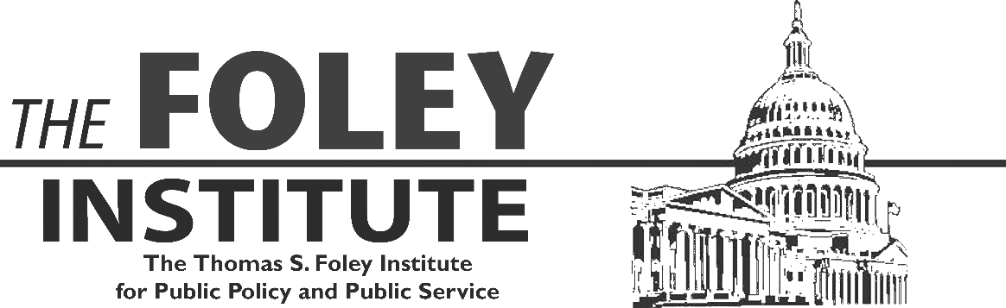
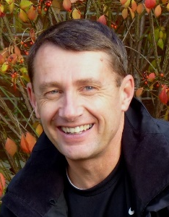
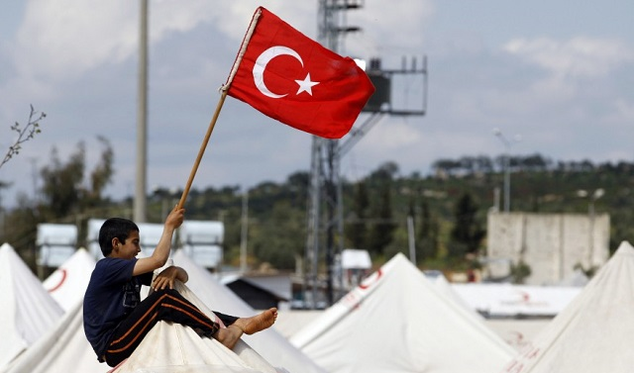
Turkey today is home to 4 million Syrian refugees. A war of words with the EU has brought its aspirations to join the EU to a standstill. The AKP, an Islamist party, is on the rise under Recep Tayyip Erdogan, but there was an attempted military coup in 2016. What does the future hold for Turkey?
Dr. Chris Kilford is a board member of the Canadian International Council, a Fellow with the Queen’s Centre for International and Defense Policy and Research Fellow with the Conference of Defense Associations Institute.

Thursday August 29 | 12:00 p.m.
Foley Speaker’s Room | 308 Bryan Hall

Pizza & Politics Series
Turkey Today
Conflict and Crisis

