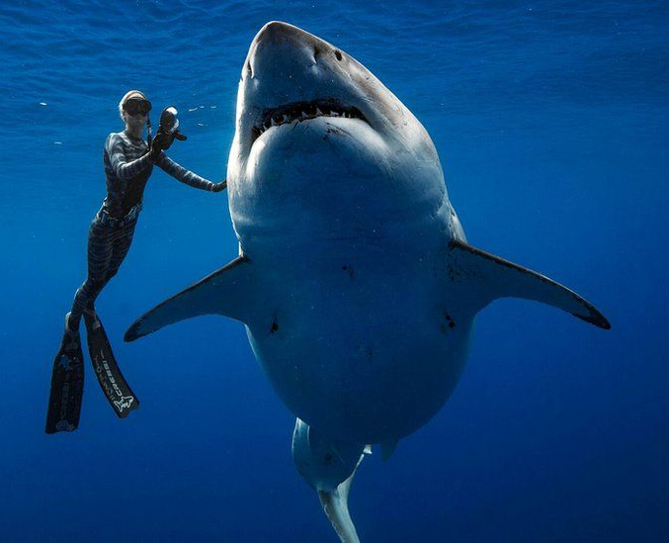  Tuesday, February 5th  Where Sharks want to be: using tracking technology to define important habitat  Guest of Honor: Dr. Charles Bangly of the Smithsonian  Dr. Charles Bangley is a postdoctoral fellow at the Smithsonian Environmental Research Center, where his research focuses on the movement ecology of coastal sharks and rays as part of the Smithsonian Movement of Life Initiative. He is a graduate of the University of Rhode Island and earned his Master’s degree and PhD at East Carolina University. His efforts to increase awareness of shark research in North Carolina have included two appearances on National Geographic’s “Shark Fest.” | 6-7 PM in the CUB Auditorium  ────  Learn More About Sharks and Conservation  ────  Free to all!  ────  WSU Zoology CLub  

