Protocol for WHEAT tissue collection or DNA submission
  - Western Regional Small Grains Genotyping Lab

Tissue Collection:

Note: Each tissue plate needs to have two different empty wells. If submitting multiple plates, the empty wells need to vary from plate to plate.

Materials:
- Scissors
- Forceps
- 70% ethanol
- Kimwipes
- Tissue plates and lids
Important: please consult with WRSGGL staff about which tissue plates and lids to use! Only certain plates/lids are suitable for preventing contamination.

Wipe scissors and forceps with 70% ethanol and then dry with a Kimwipe between samples.

At the two-leaf stage (about two-week old seedlings), collect four to five pieces of approximately 2-2.5 cm of leaf tissue in each well of a 96-well tissue plate. Tissue should be 1 cm below the top of the well.

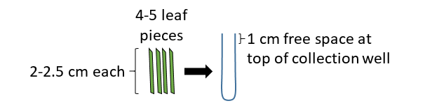

Do not fold or wad the tissue, and do not place too much tissue in the wells as this will result in poor lyophilization and tissue grinding.

Cover the plates securely with the lids.

Lyophilizing the tissue:

Freeze the samples for at least 1 hour at -80°C before lyophilizing the tissue.

Remove the lid and cover the plate with a Kimwipe or paper towel to prevent contamination (secure with lab tape). Make sure tissue is COMPLETELY dry. Three to four days of lyophilization should be sufficient.

Once the tissue is completely lyophilized, securely cover the plates with the lid (do not use adhesive covers) and ship overnight (no dry ice needed for shipping dried tissue).

If sending tissue that is not lyophilized, make sure it is completely frozen BEFORE packaging and shipping. Ship overnight on dry ice.

If submitting DNA:

Different jobs have different DNA requirements. Please consult with a WRSGGL staff member regarding the volume and concentration required.

Each plate needs to have two different empty wells. If submitting multiple plates, the empty wells need to vary from plate to plate. DNA should be in 96-well plates sealed with Bio-Rad Microseal ‘B’ PCR Plate Sealing Film or equivalent. All samples must be completely frozen BEFORE packaging and shipping. Ship overnight on dry ice.

Shipping:

Samples should be packaged tightly so that they do not move around during transit. Dried samples are brittle and can be easily damaged.

Ship overnight to:
Deven See
USDA-WRSGGL
Clark Hall, Room 287
410 SE Dairy Road
Washington State University
Pullman, WA 99164-6420

Email the completed Plate Layout Submission Document to Deven_See@wsu.edu. When submitting multiple plates, please list all the samples in a single Excel document and a single worksheet rather than having separate files and worksheets for each plate. Just keep adding the samples in the rows without any break between plates.

