A Week of Service in the

Stillaguamish Valley
March 12-19, 2016

Following the SR530 Mudslide in March 2014, Washington State University has committed resources and time to recovery efforts in the Stillaguamish Valley for five years. As part of this commitment, WSU Extension is partnering with the City of Arlington and Town of Darrington to sponsor a week of service in the Stillaguamish Valley March 12-19, 2016.
A Week of Service in the Stillaguamish Valley will be a community revitalization focused event. This event is a progressive event that will start in Arlington, WA and will progress up the Stillaguamish Valley to Darrington, WA throughout the week. March 12-15 will be spent in the Arlington area and March 16-19 will be spent in the Darrington Area.
Our goal, as event organizers, is to get volunteers and community members invested in the Stillaguamish Valley Community, help give the community a fresh look, and highlight the existing community pride.
Over 35 university students will be working alongside local alumni, youth organizations, and community members to help revitalize the Stillaguamish Valley community. Volunteers will work on projects that include painting, small construction, cleaning, forestry work and many other opportunities. The event is family friendly and we encourage you to gather your friends and family and bring them out to help as well! Every hour donated will benefit the community greater!
Volunteers are encouraged to donate as much time as they can and work throughout the valley, the opportunity is not restricted by zip code. This event is a great opportunity to get involved locally, work alongside groups from across the community and state, and show your commitment to the community.
If you are a local business or organization that has a project request, contact the event organizer below for a project application or go to http://mudsliderecovery.wsu.edu. Information can be found under the “Events” tab.
The communities of Arlington, Darrington, and Washington State University Extension would like to extend our sincerest gratitude for your investment in the future of the Stillaguamish Valley.
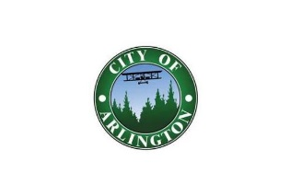

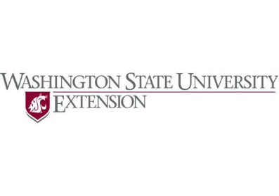
If you have any questions, need a project application, or would like to commit ahead of time, please contact Colby Cavanaugh via email at ffacolby.cavanaugh@wsu.edu.

