
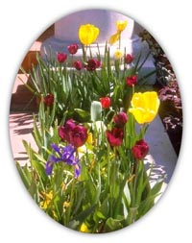
Do you have a successful garden in Ferry County?

WSU Ferry County Extension Master Gardeners are organizing a day tour July 19, 2014, Saturday of local residents’ gardens. If you have owner built rock walls, unique greenhouses, old or newly constructed gardens or landscapes, fruit orchards, cut flower gardens, herbal gardens, vegetable gardens, water gardens, raised beds, drip irrigation, or any other unique feature you wish to share please fill out this form and submit to WSU Ferry County Extension.

Name:

Email: Phone:

Address (please include directions):

More questions on back

Garden type or unique feature(s):

Restroom facilities:
- Yes No

Notes:

You will be contacted for an on-site visit and to discuss the hosting of your garden(s).

Z:\WSU Office\WSU-1\Master Gardener\Garden Tour\2014\Do you have a successful garden in Ferry County.docx
Extension programs and employment are available to all without discrimination. Evidence of noncompliance may be reported through your local Extension office. We provide services for those with Limited English Proficiency (LEP). Contact our office if we can assist you. Persons with a disability requiring special accommodations while participating in any of the 4-H programs may contact WSU Ferry County Extension at 350 E. Delaware Ave. #9 Republic, WA 99166, (509) 775-5225, X1116 or jordant@wsu.edu at least five days before the program.

