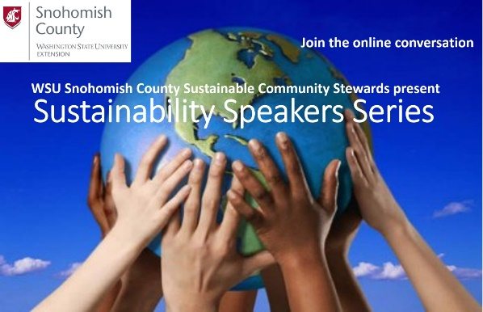
WSU Snohomish County Extension Sustainable Community Stewards

Sustainability Speaker Series

2020 Autumn

August 19th – Recording on YouTube

#Move the Date: Learning about Earth Overshoot Day with Dr. Patricia Townsend and Dr. April Atwood

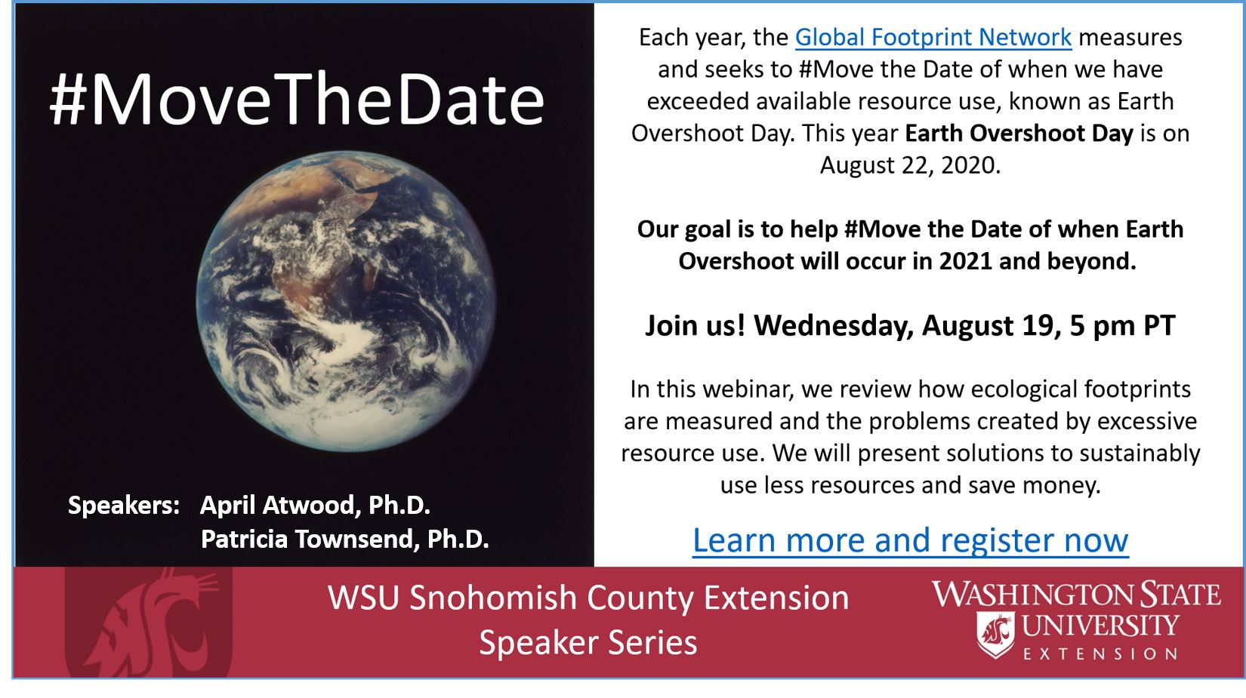

We are currently using resources at a rate equivalent to 1.6 Earths when we only have one. These patterns are not sustainable and will impact future generations. Each year, the Global Footprint Network measures and seeks to #Move the Date of when we have exceeded available resource use, known as Earth Overshoot Day. This year Earth Overshoot Day is on August 22, 2020. In this webinar, we shall review how ecological footprints are measured and the problems created by excessive resource use. We will present solutions for how to sustainably use less resources and save money. Our goal is to help #Move the Date of when Earth Overshoot will occur in 2021 and beyond.

Speakers Bios:
Dr. April Atwood is a Senior Instructor teaching marketing, consumer psychology, and sustainable business. She has spent decades teaching courses related to these topics at University of Washington, Bainbridge Graduate Institute, Presidio Graduate School, and now at Seattle University. She is deeply interested in environment and sustainability issues, as evidenced by her service to King County Solid Waste (as VP of the Solid Waste Advisory Committee), to her hometown (as a Master Naturalist for Bellevue Parks and Recreation), to her region (as Beach Naturalist for Seattle Aquarium), and her work as a Climate Reality Leadership Fellow (trained by Al Gore). She teaches, writes, and speaks on a variety of consumer and sustainability-related topics, including considered consumption, better business models, and measuring impacts.

Dr. Patricia Townsend is a Regional Extension Specialist for Washington State University (WSU) Extension. In this position, Patricia works with stakeholders throughout the Pacific Northwest on issues related to renewable energy, ecosystem services, and green infrastructure. She recently joined WSU’s Metropolitan Center for Applied Research and Extension. Patricia also leads outreach for Advanced Hardwood Biofuels Northwest, which includes energy literacy, stakeholder research, and connecting poplar growers with market opportunities. In her dissertation research, she worked closely with landowners and local conservation practitioners to find realistic solutions to land degradation and planning for climate change in Costa Rica. Currently, she is happy to be doing research and outreach on poplar trees and green infrastructure to build sustainable systems in the Pacific Northwest. Patricia received a Ph.D. from the University of Washington and a M.S. from the University of Florida.
__________________________________________________________________________

September 16th – Recording On YouTube

Transform Your “Use-less Stuff” into New!

Innovative and Actionable Upcycling Projects with Jolene Jang

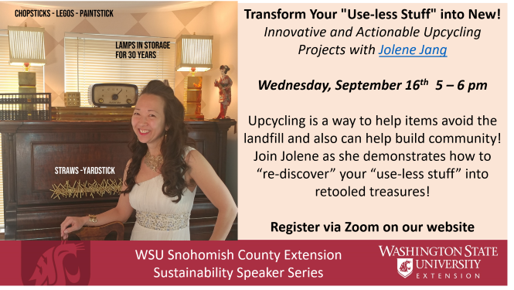

When you look around your home do you see miscellaneous stuff laying around? Discarded items that seem to have outlived their purpose? What if instead we turned that “use-less stuff” into retooled treasures? Upcycling is a way to help items avoid the landfill and also can help build community! Once you can mind-shift and be content at home with what you have you will be delighted with your ability to re-purpose, re-invent, re-tool, or even re-pair with added flare! Bring new life to your surroundings and your “stuff.” After participating in this presentation you will find yourself exercising your right brain in a way that helps you begin to see how to make something out of “nothing” with a new creative lens-focus!

Speaker Bios:
Jolene Jang (formerly known as The Fun Specialist) has taken her creativity to a new level! As a graduate of the University of Puget Sound with a BA and emphasis in marketing, she uses marketing prowess every day. In her 25 years of business as an entrepreneur, most of her professional career has been in corporate team building and professional speaking on maximizing meetings for Fortune 500 companies. Jolene has been interviewed on most major news media outlets for her attitude, creativity, and innovation. On her YouTube channel she shares a variety of exploration of neuroscience, culture, innovation, life and biohacking, peppered with quirky bits of new and different with a fun do it yourself point of view.
________________________________________________________________

October 21st – Recording on YouTube

Green Gardening and Sustainable Landscapes:
with WSU Master Gardeners Jason Hammond and Robert Petersen
Presentation slides: Introduction-to-Green-Gardens-Sustainable-Landscapes_10-21-2020

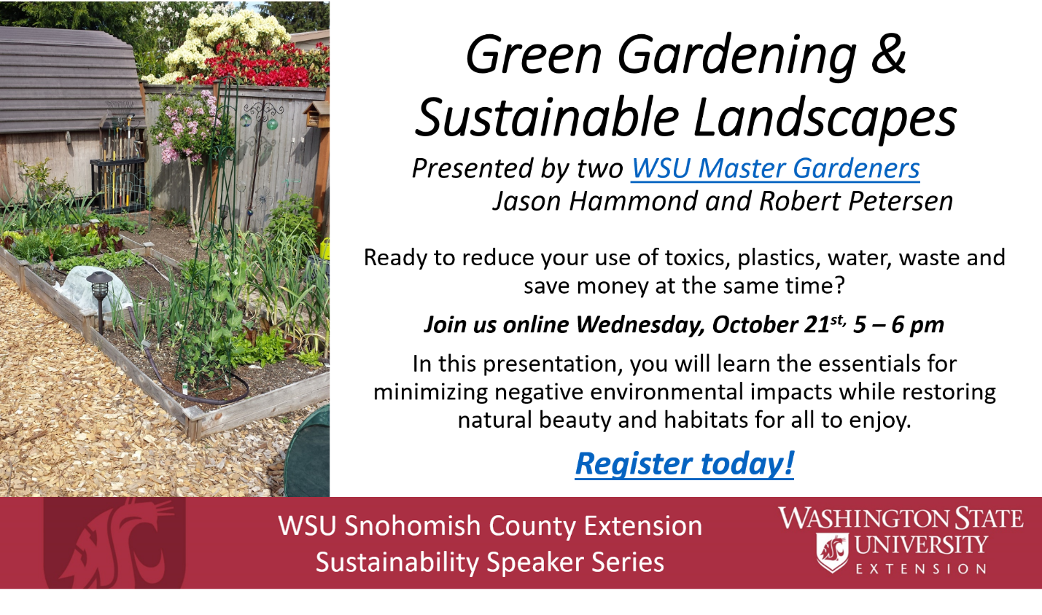

The terms “green” and “sustainable” have begun to establish a trendy presence in our daily vocabularies, but when it comes to gardens and landscapes, what do these terms really mean? In this presentation, you will learn the essentials for minimizing negative environmental impacts while restoring natural beauty and habitats for all to enjoy. Specifically, this presentation will help you learn ways to reduce use of: toxics, plastics and water, along with some inspirational upcycling ideas for your gardening décor!

Speakers Bios:
Robert Petersen first became active as a volunteer with WSU Snohomish County Extension starting as a Master Gardener in 2014. He then expanded into Natural Yard Care plus Rain Garden Support in 2016 and 2017, and became a Sustainable Community Steward in 2018! Robert currently does vegetable and berry gardening using raised beds as well as native soil gardens. He also manages tidy ornamental gardens as well as “natural gardens” where he “lets whatever pops up remain” (as long as it isn’t what he determines is a weed). He considers himself a sustainable gardener, not being obsessed with having immaculate gardens.

Jason Hammond is an avid gardener with a passion for natural and sustainable urban food production. He is a Certified Master Gardener, a Certified Master Beekeeper Apprentice, and raises free-range organic chickens, ducks, and quail. He is currently building his homestead on Whidbey Island.
________________________________________________________________

Thursday – November 12th

Planning for Your (Greener) Holidays – Recording on YouTube
With King County Eco Consumer, Tom Watson

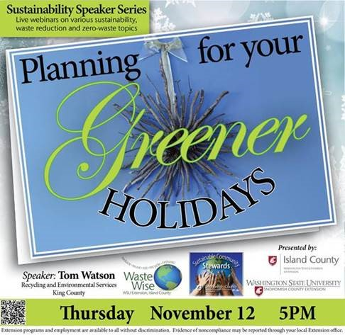

With COVID impacting all of our lives, what better time than now to buck tradition and plant the seed of new ways of celebrating in a way that is kinder to the earth? Everything you need to think about from Shopping Sustainably, Green Gift Giving, Eco-tastic Decorating, Entertaining Tips and Recycling the Holidays will be featured in this fun and idea inspiring presentation from the Eco Consumer, Tom Watson of King County Solid Waste.

Speaker Bio:
Tom Watson has worked on waste reduction and recycling for King County for 28 years. His EcoConsumer public outreach projects include TV and radio work, the King County free community repair events program, and the annual Green Holidays program.

November 18th

Understanding Carbon Offsets – Recording on YouTube

Presented by Stan Gent, with support from Puget Sound Energy and Snohomish County PUD

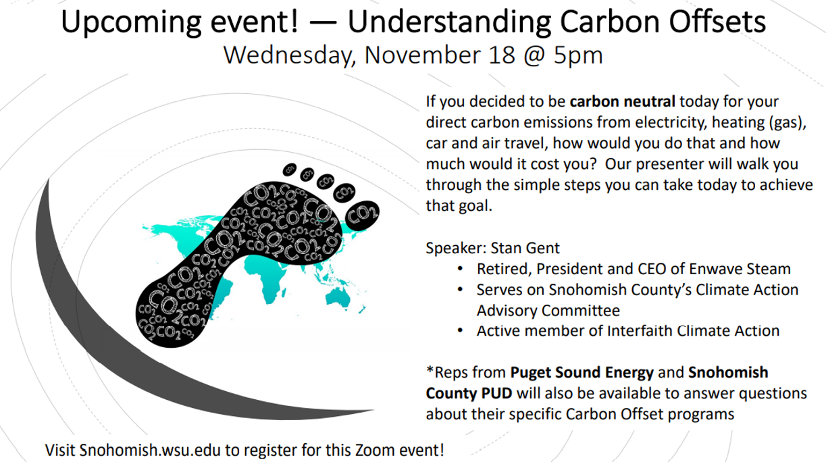

If you decided to be carbon neutral today for your direct carbon emissions from electricity, heating (gas), car and air travel, how would you do that and how much would it cost you? Our presenter will walk you through the simple steps you can take today to achieve that goal. You might be surprised by the affordable cost! Representatives from Puget Sound Energy and Snohomish County PUD will be available to answer questions about their specific Carbon Offset programs.

Speaker Bio:
Stan Gent PE, has extensive experience working with energy systems across North America. Prior to his retirement in 2016, he was President and CEO of Enwave Steam (formerly Seattle Steam Company). He has been actively involved in many professional boards including founding member of the Washington Business Alliance (formerly Washington Clean Tech Alliance), Seattle Mayor’s Green Building Task Force, the Seattle Chamber of Commerce, the Seattle Rotary Sustainability Committee, and Department of Mechanical Engineering Advisory Board for the UW’s College of Engineering. He currently serves on Snohomish County’s Climate Action Advisory Committee and is an active member of Interfaith Climate Action. In 2014 Stan was recognized by the International District Energy Association for lifelong career commitment to energy efficiency and professional contributions to advancing the global district energy industry. He holds a Mechanical Engineering degree from Queens University Belfast.

