4-H Career Education Opportunity



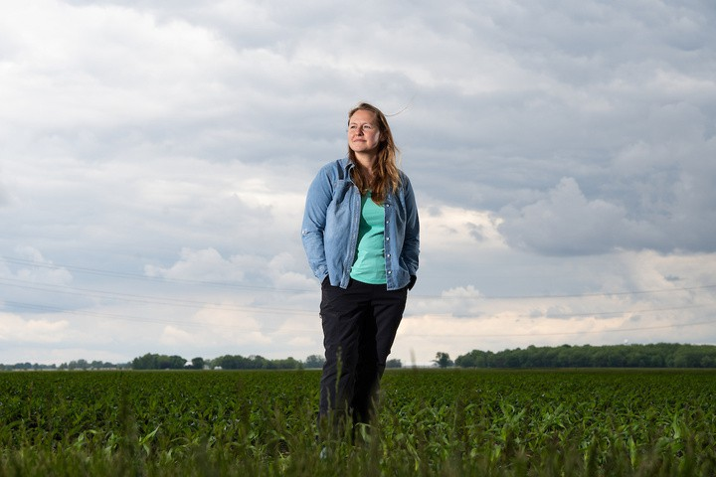

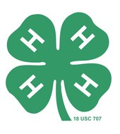

Agronomy E-Learning Academy Scholarship

Things To Know:
Your fees will be covered by a grant from the Ballmer Group.
Check out all three courses and the Crop Professional certification at this link.
Classes are asynchronous, so they fit around your schedule.
4-H student support (sign-up, career exploration, office hours, etc.) is provided by 4-H educators.
Earn Your Crop Professional Certificate by May 2027 Earn all three digital badges
(Agronomy Essentials--June 2026, Nutrient Management--September 2026 and Precision Agriculture--January 2027) and you will receive your industry-recognized Purdue Agronomy Crop Professional Certificate.

Each 12-Week Digital Badge
Approximately 30 Hours Of Work

How To Apply:
Current sophomores and juniors, fill out the attached application
Attach your current high-school transcripts

Send application and transcripts to: wdecker@purdue.edu

Applications Due: April 20, 2026

An equal access/equal opportunity university

