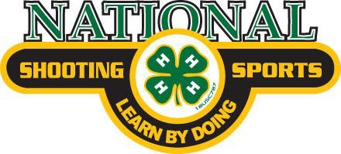
For WSU 4-H Shooting Sports Ambassadors application and instructions page: bit.ly/ShootingSportsYouthAmbassadors

National 4-H Shooting Sports Teen Leadership Institute Certification Form
I will be active in my club and county 4-H program, as well as maintain an acceptable academic standard in school during my service as a 4-H Shooting Sports Ambassador. Further, I am willing to conduct myself to the highest standards expected of an ambassador.

Applicant’s Signature
Date

We understand that our 4-H’er wishes to serve as a 4-H Shooting Sports Ambassador. We will support them in fulfilling the responsibilities should they be selected (only 1 parent/guardian signature required).

Parent/Guardian Signature
Date

Parent/Guardian Signature
Date

We certify that the above named 4-H’er is enrolled, active and in good standing in our 4-H shooting sports club and county 4-H program. We support their application for the position of 4-H Shooting Sports Ambassador.

4-H Club Leader Signature
Date

Extension Agent Signature
Date

State 4-H Shooting
Sports Coordinator Signature
(for office use only – we will complete this line)
Date

