
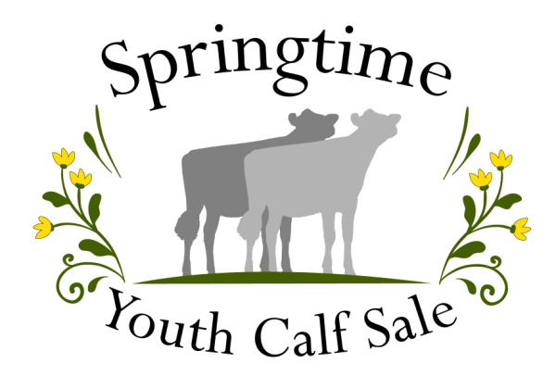
Use the QR code or visit our website
for an accessible version of this form.

POSTMARKED BY March 2, 2026
Scholarship Application

The Springtime Youth Calf Sale is providing two-$500 scholarships to applicants that meet the following qualifications.

Qualifications:
- Must have purchased a calf, sold a calf or helped significantly at the Springtime Youth Calf Sale.
- Must be or have been enrolled in 4-H or FFA
- Senior in high school or currently attending college. Must have not reached their 21st birthday before January 1.
- May apply again if previously awarded a scholarship, but preference will go to those who have not received an award.

Required:
- Typed on single sheets (not back to back) of white paper.
- Two letters of recommendation on WHITE paper;
- One of which must be from an academic advisor or school official on institution letterhead.
- The other should be from someone who knows you personally and what you have accomplished.

Awards will be announced by March 31, 2026. Awarded after completion of 1st quarter or semester of school year in the fall. You must contact the SYCS – we will not be contacting you. You need to provide a letter of request with current address and show proof of attending school.

Name__________________________________Date of Birth________

Address________________________________________________

City____________________________State_______Zip__________

Phone #____________________________

Email______________________________

Parent’s Name______________________________________________

College or Vocational school you plan to attend?____________________

Selected Major or Program___________________________________

High School GPA_______ or College GPA_______

I certify that all information provided is complete and true.

Signature of Applicant Date

Postmarked By March 2, 2026

Return To: Liz Holtcamp, 10291 Ridge Place, Sedro-Woolley, WA 98284. (360) 488-3144
Please answer the following questions in paragraphs or essay form on a separate piece of WHITE paper. Limit your application to two pages.

- Introduce yourself. Tell where you live, when and why you became involved in 4-H or FFA opportunities.
- Highlight your 4-H or FFA projects, activities and involvement, including major learning experiences, special interests and achievements.

- List some of your school activities, accomplishments and leadership activities.
- List any community memberships and activities.
- Why do you wish to pursue your major or program listed above?
- What are your current goals and objectives (personal, educational and career goals) for your future?
- How are you or will you be financing your college education?
- Explain a special event or moment with your 4-H or FFA Dairy projects.

