
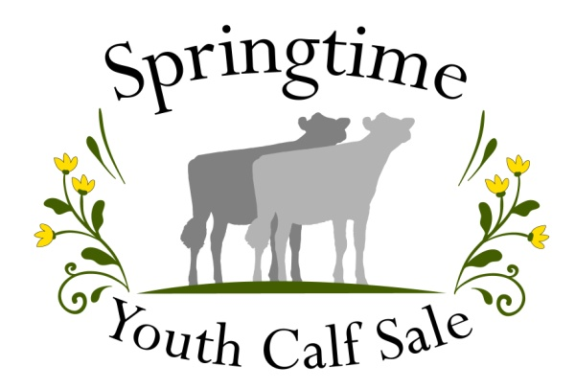
Use the QR code or visit our website
for an accessible version of this form.

Calf Grant Essay Contest
Due: February 23, 2026

Grant Purpose
Provide a $500 grant to qualified 4-H/FFA members to help with the purchase of a registered dairy project heifer.

Eligibility Requirements
- Be a currently active 4-H or FFA member (9 to 18 yrs of age) enrolled in dairy in WA
- A registered dairy heifer (under 2 yrs of age), for the 2026 show season, must be purchased and transferred into the applicant's name.

Contest Rules
Grant winners that are successful in purchasing a calf must agree to:
- Exhibit and show the animal in at least one 2026 show or fair
- Write a personal “Thank You” letter to the consigner of the calf
- Write a personal “Thank You” to the grant donors. A list will be provided. Thank you’s need to be sent before receiving the grant payment.
- Announced before March 31, 2026.

How to Enter
- Fill out the attached application form
- Answer the questions listed below. Answers must be typed and single sided.
  - What 2025 personal goals did you achieve and how will each one benefit you in the future?
  - What activities and projects (Personal, Family, School, Faith, Community) have you chosen to accomplish in 2026 that will develop and improve your (non-dairy related) skills and abilities?
  - What is your career goal? Why did you choose that as your career?
  - How might friendships you make and your behavior choices influence life’s successes?
  - List the names of two people outside your family who have especially inspired you to work hard and consistently to make personal improvements. How did each one inspire you?
  - What benefits have you experienced from your volunteering or community service?
  - Outline your financial arrangements to cover the anticipated 2026 expenses for your project (feed, housing, health care, transportation, exhibiting at fairs, breeding, etc.).

- Return application form and essay questions by February 23, 2026 via mail or email
Liz Holtcamp  10291 Ridge Place  Sedro-Wolley, WA 98284 | sycs4h@gmail.com

Applicant Information
Name: | Age on 1/1/2026:
Club/Chapter: | Years in 4-H/FFA:
Address:

Parent’s Names:
Email Address:
Phone Number:

Eligibility Checklist
Are you currently an active 4-H or FFA member enrolled in dairy? | - Yes | - No
Have you received a calf grant previously? | - Yes | - No
I have completed and attached my answers to the essay questions. | - Yes | - No
I have read and agreed to the contest rules outlined on the previous page. | - Yes | - No

Applicant Signature: | Date:

Return application form and essay questions by February 23, 2026 via mail or email
Liz Holtcamp  10291 Ridge Place  Sedro-Wolley, WA 98284 | sycs4h@gmail.com

