Selling Your Livestock Project
When Fair is Canceled: A Guide for Youth & Families

Introduction/Background:
There are times when a fair or exhibition may have to cancel or delay. There are times when your plans change and the fair will not work into your schedule. There are times when your project animal gets sick or injured altering your course for the fair or exhibition. Uncertainty can cause heartache for youth and families who have devoted their time, energy and financial resources to their projects. It also affects those that have to make and communicate the hard decisions. Everyone is working together to help in a time of uncertainty. Clear communication with all parties involved is vital such as fair boards, livestock committees, youth & families, fair management/superintendents/ volunteers and processors.
Washington State University Extension is here to help. We are offering tools for youth and families who are looking for direction in the case of a fair or exhibition cancellation. Positive youth development that is guided by a caring adult (parent/guardian, other family member, advisor and/or educator) provide hands-on learner engaged experiences that help youth in vital life skill development. We understand that livestock projects require financial investment and that there may be concerns about financial hardships relating to not having a fair and subsequent auction to sell your animal. If this unfortunate scenario happens the information following will assist youth and families in navigating livestock projects and aid in completing the learning experience.
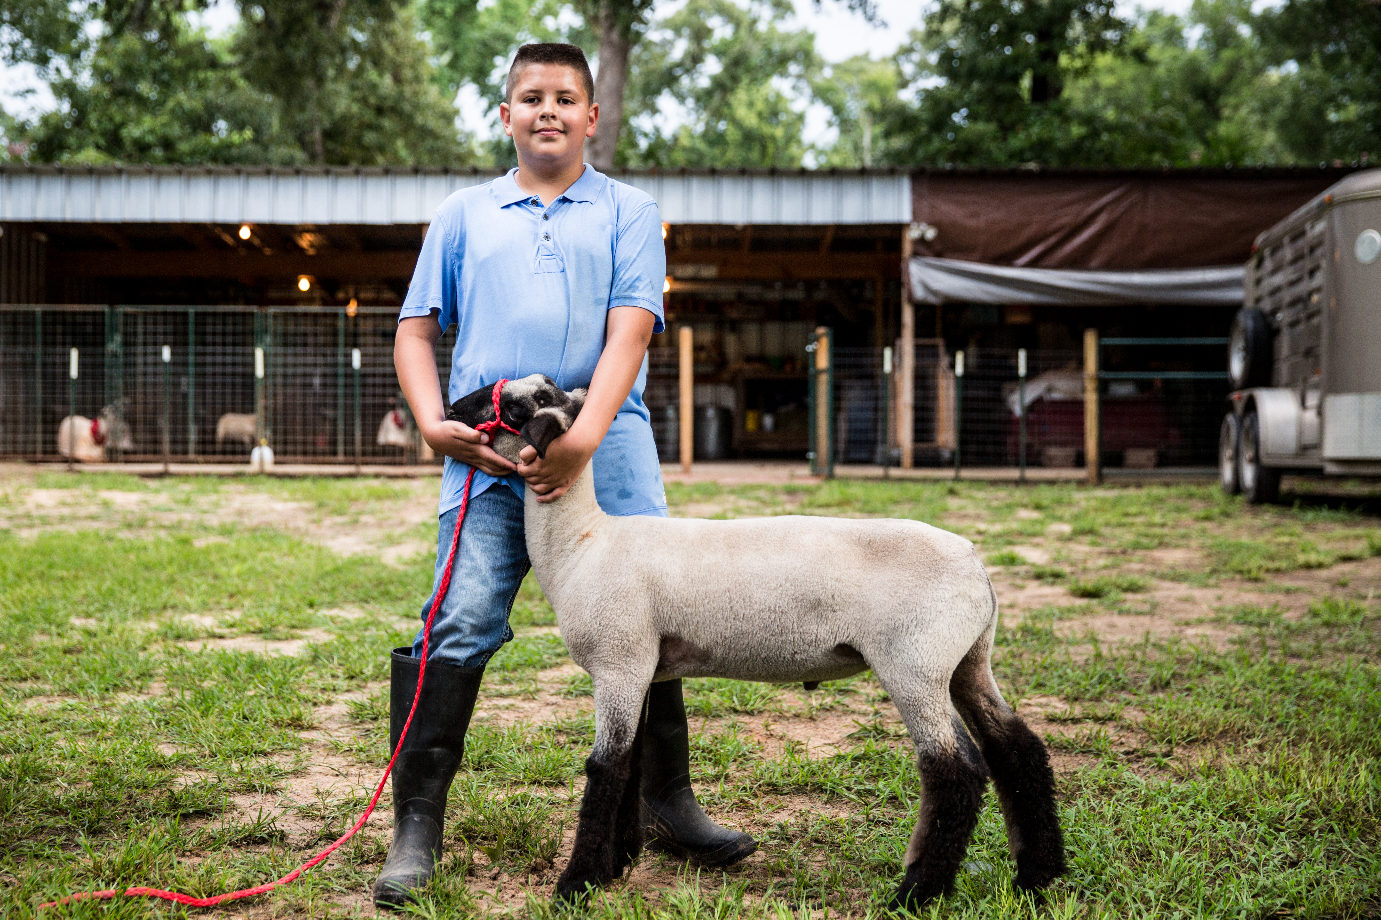


Normally, a youth livestock member would be able to sell their animal at the auction during the fair, with assistance from a sale committee and the community. If a fair is cancelled, the big question becomes: whom can I sell my animal to? See the below list for your options. Please be aware that the buyers of your animal will depend on where they will be harvested.
Whom can I sell my animal to?

- Using custom slaughter and processing (see chart below for more info on custom)
  - Private buyer (s):
    - Beef- ⅛ animal, ¼ animal. ½ animal, whole animal
    - Lamb and Pork- ½ or whole animals
  - Packer/ meat processor: Ask your local packers and meat processors if they would be interested in purchasing your animal.

- Using USDA inspected slaughter and processing (see chart below for more info on USDA)
  - Private buyer (s):
    - Beef- ⅛, ¼, ½, whole animal, boxed beef packs, or individual meat cuts
    - Lamb and Pork- ½, whole, boxed beef packs, or individual meat cuts
  - Retail outlets such as a restaurants, grocery stores, and farmers markets:
    - Beef- ⅛, ¼, ½, whole animal, boxed beef packs, or individual meat cuts
    - Lamb and Pork- ½, whole, boxed beef packs, or individual meat cuts
  - Packer/ meat processor (ask your livestock sale committee for recommendation on this, they gather the packers for the auction)
    - Ask your local packers and meat processors if they would be interested in purchasing your animal.

Custom Slaughter and Processing  - Animals sold to private buyer, prior to slaughter based on $/head or liveweight.  - Can be sold as ⅛, ¼, ½, or whole.  - Brand inspection required before slaughter.  - Transfer of ownership must occur before the slaughter of the animal.  - Must be slaughtered by WSDA certified custom farm mobile slaughter unit or custom slaughter facility.  - Must be processed and packaged at WSDA certified custom slaughter facility.  - The person purchasing the animal (or portion of animal), must take the meat product home. This product CANNOT be resold or given to anyone other than the buyer.  - No out-of-state sales allowed. | USDA Slaughter and Processing  - Animal sold to private buyer or retail markets using $/head, live weight, hot carcass weight, or weight of meat product (boxed meat).  - Can be sold as ⅛, ¼, ½, whole, boxed beef packages, or individual cuts.  - Brand inspection slip must be provided to the USDA inspected facility.  - The product must be slaughtered and processed in a USDA inspected facility.  - This product can be sold as a meat product to restaurants, farmers markets, grocery stores, as smaller meat packages, etc.  - Sales can occur after the slaughter and processing of the animal and product.  - Sales can be made out-of state.

How do I price my animal?

- Custom Slaughter & Processing
  - Per head- selling the animal for a flat rate (Example: $750 for 1 hog).
    - Easiest option
  - Liveweight- selling on a price per lb of live weight (Example: $3.00/lb for a $250lb hog)
    - Requires a scale for a certified liveweight

- USDA Slaughter & Processing
  - Per head- selling the animal for a flat rate (Example: $750 for 1 hog).
    - Easiest option
  - Liveweight- selling on a price per lb of live weight (Example: $3.00/lb for a $250lb hog)
    - Requires a scale for a certified liveweight
  - Hot Carcass Weight- weight after slaughter, provided by slaughter facility
  - Price per lb of retail meat cuts- using a price per lb determined for each specific cut (Example: $8.99/lb for ribeye steak)
    - Requires weighing individual cuts to determine total price
  - Box beef packages- selling a box with a pre-determined variety of cuts (2 ribeye steaks, 2 new york strips, 6 cubed steaks, 10lbs of ground beef) and predetermined price (Example: $80 per box).
    - Requires pre-planning of the boxes and work to divide and sell the individual boxes of beef.
    - Requires pre-determining of a reasonable price
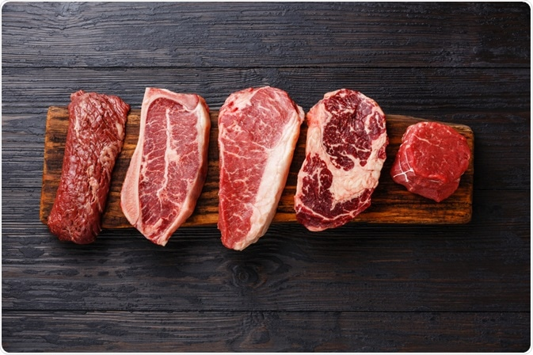

How much should I ask for my animal?

We hope all our youth livestock producers have been keeping records on the livestock projects. Do you need help deciding what to charge for your livestock product? Let’s start! What are the costs associated with your project animal? You then have to decide if you are selling by the head or by the pound.
Note: if you sell by the pound you need a weight across a certified scale at time of sell if selling by the pound.

Hog Example | Selling $/head | Selling  Certified Weight  $/lb | Your animal | $
Cost of animal | $200.00 | $200.00 | Cost of animal | $
Feed | $200.00 | $200.00 | Feed | $
Vet/animal health  (dewormer/vaccines) | $25.00 | $25.00 | Vet/animal health | $
Equipment | $25.00 | $25.00 | Equipment | $
Cost Total | $450.00 | $450.00 | Total | $
Weight of animal | Estimated 250lbs | Actual Certified Weight  250lbs | Est. weight of animal | lbs.
Breakeven $ = no profit/no loss | $450.00 (same as cost) | $1.80/lb (which is $450.00)
Sold Price of Animal | $750.00 | $3.00/lb ($750) | - Sold animal for flat rate______  - Sold animal $/lb _____ | $
Profit | $300.00 | $300.00 | Profit | $

How do I know when my animal will be
ready for harvest?

You will need to make an appointment for slaughtering and harvesting of your animal months ahead of time, so you will need to make an educated prediction on when your animal should be ready for harvest. In order to do so, please use the following equations and information to determine how many days until your animal is ready to be harvested.
Days until harvest = (Goal Final Weight - Current Weight) / Average Daily Gain
Average Daily Gain = (Current body weight - starting body weight) / (Current date - starting date)
Or use the following estimates for average daily gain. These estimates are based on average growing, moderate framed animals. Some breeds will grow faster or slower than the average. These average daily gains will only be achieved when feeding the above the maintenance needs of the animal, using concentrate diets.
 | Grower Pigs, less than 110lbs | Finisher Pigs, more than 110lbs | Lambs | Steers, less than 800lbs  Backgrounding/grower diet | Steers, more than 800lbs  Grain/finishing diet
Predicted Average Daily Gain | 1.6lbs/day | 2.0lbs/day | 0.60lbs/day | 2.0lbs/day | 3.0lbs/day

Average final weights:
Please be aware that if you are doing an online show or auction, they will have their own specifications on weight minimums and maximums, please follow their guidelines. Also, these finishing weight averages are based on moderately framed and sized animals. Breeds that are larger in frame or muscling may have increased final finishing weights that are ideal for them and animals that are smaller framed or with less muscling may benefit from a lower finishing weight. Note: Check with you premium book or fair/exhibition officials about the desired weight range. The ones that are listed below may or may not be what your local fair/exhibition has listed.
Hogs: 230-300lbs
Lambs: 100-140lbs
Goats: 60-120lbs, this one varies greatly depending on the breed of goat, please use breed averages here.
Steers/beef: 1100-1400lbs
***Use your predicted finishing date to schedule a time for harvest and then make sure to feed according to your goal average daily gains and finishing weight.
Please contact a processor now and make a reservation for your animal. It is essential not to wait until the last minute to try to make a reservation. Please use the following links and information to find the correct custom or USDA inspected facility to make an appointment:
Make a Reservation with a Butcher
- For a list of WSDA licensed custom slaughter and custom meat processing facilities, contact Food Safety by calling (360) 902-1876 or email at foodsafety@agr.wa.gov. Or contact your local WSU Extension Office.

- For information regarding USDA Inspected facilities in the Pacific Northwest, contact the USDA Food Safety and Inspection Service District Office (for Washington State) in Denver, Colorado at (303) 236- 9800 or visit www.fsis.usda.gov/wps/portal/fsis/topics/inspection/mpi-directory.

- For information on local Mobile Slaughtering Units (MSU’s) go to: The national Niche Meat Processor Assistance Network (NMPAN) is an excellent resource for learning more about MSUs: http://www.nichemeatprocessing.org/mobile-unit-overview.

Marketing & Advertising

Marketing and advertising is a vast part of the youth market livestock project. Since the traditional market livestock auctions and sales cannot occur, youth need to be creative and resourceful to help them successfully sell their market livestock projects. Knowledge, accuracy and honesty is fundamental in youth’s livestock project advertisement labeling such as a product that is organic, natural, antibiotic free, no hormones etc. Youth are encouraged to advertise their projects in their community and safely use the social media platform. Youth can showcase their leadership to illustrate their project through
- Photography of their project.
- Creative writing skills in a youth livestock project story to share with potential buyers.
- Financial management plan with projected earnings from selling your livestock i.e. purchase the next livestock project, buy your first car, college, savings etc.

Tips for youth to market their livestock projects:
- Buy a local product.
- Support youth livestock producers.
- Support the livestock industry.
- Great “freezer full” feeling.
- Quick & easy buying process.
- Save money when compared to grocery store prices.
- Youth for the Quality Care of Animals - YQCA certified livestock producers can communicate with their buyers that they have learned about food safety, animal well-being and enhanced life skills.

Additional Information

Brand Inspection, Haul Slip, Etc.

According to WAC 16-610-015 A certificate of permit (WSDA form #7020), commonly known as a "transportation permit" or a "haul slip," must accompany livestock: All beef exhibitors must show proof of ownership of their animals. A brand clearance and haul slip or transportation permit is required on all beef animals at USDA slaughter facilities. Brand clearance is not required at private/custom slaughtering facilities (but is required in order to sell the animal, prior to slaughter). Out-of-state animals must have a brand inspection from the state of origin.

Transfer of Ownership
Ownership of the market animal must be transferred from you to your private buyer prior to processing. Use the template agreement. See the example from the WSU Market Livestock Transfer of Ownership Template. 4-H Market Animal Transfer of Ownership Guide: (PDF) (Word) 4-H Market Animal Transfer of Ownership Guide

Online Shows/Auctions
Some fairs and exhibitions may offer online shows and possibly auctions. You need to follow the policies and procedures provided by your individual county. If they are having a virtual fair and auction, they will all have their own requirements for selling livestock. These regulations need to be followed. Be sure to work with your local officials as each may have expectations or guidelines. Remember that if an animal is exhibited in a traditional or virtual fair/exhibition the then cannot be transferred to another individual within and organization (4-H, FFA, etc.) or across an organization (4-H, FFA, etc.) for the same purpose (MOU between WA FFA and WSU 4-H, 2018). Market animal shows with a sale attached means the animal is ready for market and should enter the food chain. If there is a question, talk with your local organizational leader and/or advisor to clear up any concerns.

Additional Thoughts
- Can the animal (gilts, ewes, heifers) be kept as breeding stock? Remember, this comes with additional costs and 24/7 care of that animal and their babies, until sold.
- Will you need to keep the animal longer than you would have if fair was not cancelled? You may not be able to get in to a meat process/butcher in the same time frame and may need to keep the animal longer than planned. This can result in increased feed costs and care.
- If you have to keep the animal longer than planned, how will you adjust their nutrition and feed so they are not over-finished (too fat) at slaughter?
- Make this a learning opportunity for youth livestock enthusiasts. They are experiencing what livestock producers experience all year, unexpected problems and uncertainty. Teach them how to find alternatives and mitigate loss based on the current situation and livestock market. This may be uncomfortable but we can turn this into a huge learning opportunity to understand the challenges that farmers, ranchers and livestock producers face each day and persevere.
Resources

4-H Market Animal Transfer of Ownership Guide: (PDF) (Word) 4-H Market Animal Transfer of Ownership Guide

WSDA. 2014. Regulations for Specific Products- Selling Beef, Pork, Lamb, Goat and Other Meat. WSDA Handbook for Small and Direct Marketing Farms. Accessible at: https://agr.wa.gov/getmedia/01d5499d-7861-4b6e-a5db-74c34503ff94/23.pdf.

Memorandum of Understanding Between Washington FFA Association and WSU Extension 4-H Youth Development Program. Accessible at: https://s3.wp.wsu.edu/uploads/sites/2050/2019/07/4H_FFA_MOA_final-Oct-2018.pdf

Talking Points for Extension Professionals to Share with Fairs/Exhibitions Regarding Youth Livestock/Food Animal Projects During Washington’s “Stay Home and Stay Healthy” Order Washington State University Extension and Washington 4-H 3/27/2020. Accessible at: https://drive.google.com/file/d/1hxvVgpxhPcOLKJ8AfANeWt17QoE27Ya_/view?usp=sharing

WAC 16-610-015. Certificate of permit. https://apps.leg.wa.gov/WAC/default.aspx?cite=16-610-015&pdf=true

(Developed by the WSU Extension 4-H Program: N. Moffitt-Hemmer, K. McCloskey, P. Kuber, & G. Varrella, last edited 05-08-2020)
Extension programs and employment are available to all without discrimination. Evidence of noncompliance may be reported through your local Extension office. Reasonable accommodations will be made for persons with disabilities and special needs who participate in 4-H events and programs. Contact Natasha Moffitt-Hemmer at the Okanogan County 4-H Extension Office at 1234 2nd Ave S., Okanogan (509-422-7239; Natasha.r.moffitt@wsu.edu) at least two weeks prior to the event.

