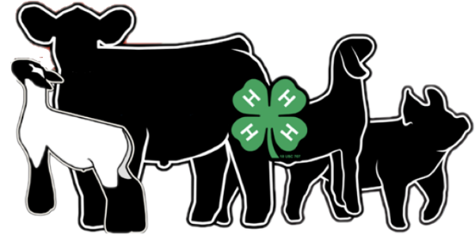
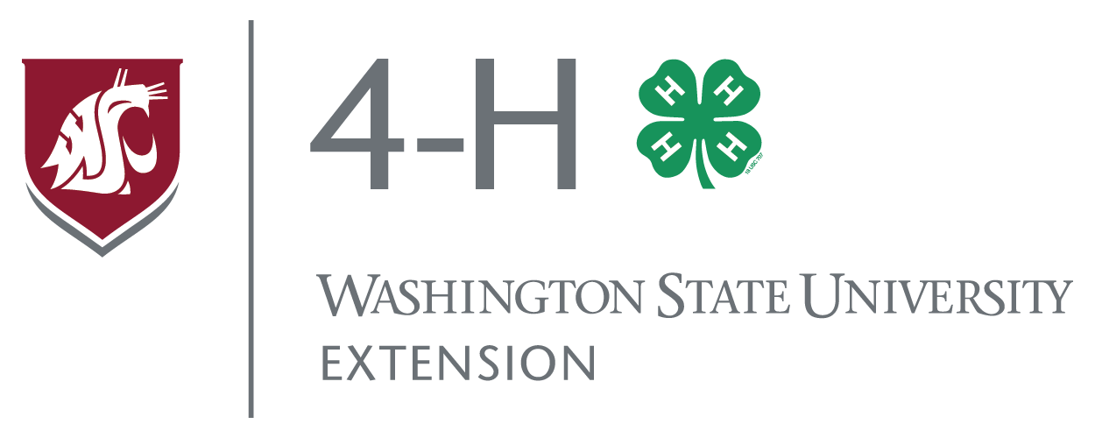

December 3, 2019

Dear 4-H Supporters,

The Spokane County 4-H Large Animal Committee is excited to share with you our exciting events planned for 2020. Our events are designed to engage youth in the livestock and agriculture industry through hands-on and experiential learning. We focus on animal husbandry, livestock judging/oral reason skills, proper fitting & showing techniques, feed & nutrition, meat industry and so much more. Our events are affordable, and our goal is to keep costs low and enable youths to invest in their projects and their futures.

Since 1904 4-H has been engaging youth in positive youth development experiences--enriching youth lives with hands on projects involving agriculture. Please help us continue this commitment. We are searching for company and individual sponsorships to help support our numerous events this year.

Final Drive Livestock Showmanship Clinic Feb 16th, 2020 Spokane County Fair Grounds

Other events:

Sponsorship Levels for Final Drive Livestock Clinic

GOLD $500.00

Title Sponsor: Logo featured, Banner display, opportunity for sponsor to speak at event.

Silver $250.00

VIP Lunch Sponsor: Logo featured, Banner display,

Bronze $100.00

Vendor Sponsor

Copper $50.00

Banner Sponsor

Virtual Livestock Judging Practice

Livestock Super Saturday

Onsite ranch livestock judging clinics

Support to national livestock judging contests and much more.

By supporting the Spokane County 4-H Large Animal Committee your organization will be making a positive impact on the youth and future leaders of our community. You will be helping them achieve their 4-H goals through these fun, safe and friendly Spokane County 4-H activities. All contributions to the Spokane County 4-H Large Animal Committee are tax-deductible; we are a tax-exempt organization with a tax identification number of 20-4537269.

Thank you for your support of our youth in Spokane County 4-H program. Please mail checks to:

WSU Spokane County 4-H Large Animal Committee
222 N. Havana St.
Spokane WA 99202

Best regards,
Kyle Cordill 509-979-8859 Kate McCloskey
Vice President 4-H Program Coordinator
Large Animal Committee Meeting 509-979-9118

Extension programs and employment are available to all without discrimination. Evidence of noncompliance may be reported through your local Extension office. Reasonable accommodations will be made for persons with disabilities and special needs who participate in 4-H events and programs. Contact Kate McCloskey at the Spokane 4-H Extension Office at 222 N. Havana, Spokane, (509-477-2165; kmccloskey@spokanecounty.org) at least two weeks prior to the event.

