BIOAg Project Report

Report Type: Final

Title: Investigating sustainable and cost-effective strategies to expand production of food quality winter pea as a viable specialty crop in Palouse

Principal Investigator(s) and Cooperator(s):

Principal Investigator: David W Crowder (WSU Entomology)
Co-Investigator: Saumik Basu (WSU Entomology)
Cooperator: Rebecca McGee (USDA ARS)

Abstract:

Winter pea could be a transformative crop in Washington due to high yields, tolerance for a wide range of environmental conditions, and providing income diversification for farmers. In contrast to spring peas, winter peas have higher nutrition and can grow in more severe environments. Yet, although acreage of winter peas is growing rapidly, there remains scant information about how farmers can promote tolerance to stress in this crop. Our work shows application of soil rhizobia promotes tolerance of spring pea to biotic stressors such as insects and viruses, but similar work is needed on winter pea. In this project we assessed how soil rhizobia affected the growth of winter pea cultivars and their tolerance to aphids and viruses. Our project meets the BioAG priority of conducting applied research that promotes more sustainable management of specialty crops and provides growers with cost-effective and eco-friendly management tactics.

Project Description:

Legumes are a key part of many crop systems in Washington. Historically, most legumes were planted in spring, but winter varieties have become available. Winter pea has the potential to be a transformative crop for Washington because it can tolerate a wide range of conditions and can be sold for human consumption. Accordingly, winter pea acreage has increased by over 50% in the past 5 yrs. In contrast to spring pea, winter pea has higher protein content and nutritional value, and can be widely used as protein beverages, snacks, baking products, baby food, and soups. Winter peas also produce considerably higher yields and can more effectively avoid drought and heat stress compared to spring pea. Although winter pea cultivation has grown rapidly over the past decade, and contracts are in high demand, further expansion is constrained by a lack of knowledge on pest management practices and how these effects might vary across cultivars.
Historically, production of spring pea has been hampered by vector-borne pathogens and insects. For example, in the Palouse region, pea aphids transmit several devastating pathogens that reduce yields of legume crops by up to 40%, and these pathogens can cause yield losses even when aphids are not apparent to growers. However, our research in spring pea shows that beneficial soil rhizobia can promote legume productivity by improving nitrogen fixation and by promoting tolerance to stressors. While the use of insecticides and nitrogen-based synthetic fertilizers are key tactics to prevent pests and boost yield, such practices produce environmental hazards, and promoting healthy soils may reduce reliance on these products.
Legume growers would benefit from a better understanding of how soil microbes may promote sustainable crop management in winter pea. We predict that beneficial soil rhizobia as seed inoculants may prove effective in improving the nutritional quality and yield of winter peas, reducing damage from insects and viruses, and allowing winter peas to flourish in more diverse conditions. Understanding how soil conditions and microbial populations might be managed to promote growth of winter peas could provide widespread benefits for Washington farmers. Our project sought to understand how soil rhizobia affected plant growth and tolerance to stress in winter pea. We had four specific objectives: (a) Assess whether soil rhizobia affect the growth of various winter pea cultivars, (b) Assess whether soil rhizobia promote tolerance of winter pea to biotic stress, (c) Identify the molecular mechanisms by which rhizobia affect winter pea, and (d) Conduct outreach to growers on benefits of rhizobia and winter pea production.

Outputs

Overview of Work Completed:

(Objective 1) Assess whether soil rhizobia affect the growth of various winter pea cultivars

In the first year of the project (2022) we hired a PhD student in Molecular Plant Sciences (Chase Baerlocher), who led the project working with Crowder and Basu. For our first experiment, we obtained three winter pea cultivars from cooperator McGee (Lynx, Wyndham, Melrose), and we tested how each cultivar responded to inoculation with soil rhizobia at planting compared with a spring pea cultivar we have worked extensively with (Banner). For each cultivar, we found that rhizobia considerably increased shoot growth, plant survival, and biomass production (Fig. 1).
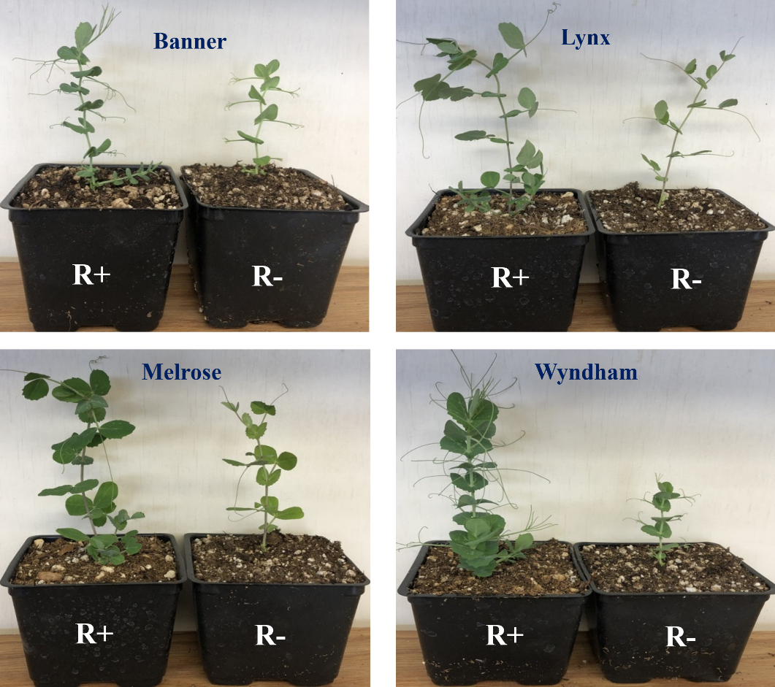
Fig. 1. Examples of the effects of seed-applied rhizobia inoculant on growth of three winter pea cultivars (Lynx, Melrose, Wyndham) and one spring pea cultivar (Banner). For each of the cultivars, inoculation of the seed promoted shoot growth compared to the plants grown without seed-applied rhizobia (see also Fig. 2). Yet, the seed-applied rhizobia inoculation actually appeared to negatively impact root growth compared to plants grown without rhizobia (see Fig. 3). Plants grown with rhizobia had greater overall survival than plants without.
(Objectives 2 & 3) Assess whether soil rhizobia promote growth and tolerance of winter pea to biotic stress and the underlying molecular mechanisms

Our first objective showed that rhizobia promoted growth of winter and spring pea cultivars. We expanded on this by testing how inoculation of winter pea seeds with rhizobia affected growth of various cultivars with biotic stressors present. Specifically, we tested if soil rhizobia promoted growth and tolerance of winter peas faced with stress from pea aphids (A. pisum) and the aphid-borne pea enation mosaic virus (PEMV). Our first experiment had a 4 × 2 × 3 design with three winter pea cultivars (Wyndham, Melrose, Lynx) and one spring pea (Banner), two rhizobia treatments (present, absent) and three aphid treatments (none, non-viruliferous, viruliferous). Pea plants were grown with or without rhizobia inoculants for 2 weeks before aphid treatments were applied for 48 h. All plants were then grown for 7 d before data were collected on root and shoot weight and nodule counts. Somewhat surprisingly, we found rhizobia inoculation led to plants with lower root weights than plants without rhizobia, but greater shoot weight (Figs. 2, 3). These effects were largely consistent regardless of whether plants were grown in control treatments or for plants that were faced with aphids and PEMV (Figs. 2, 3).
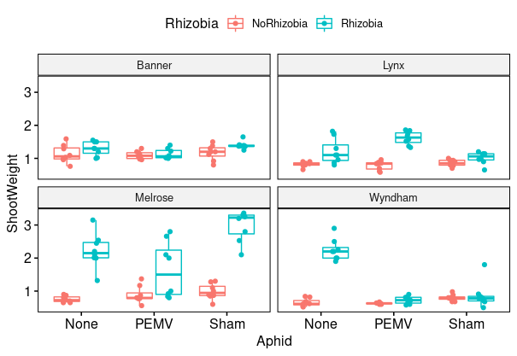
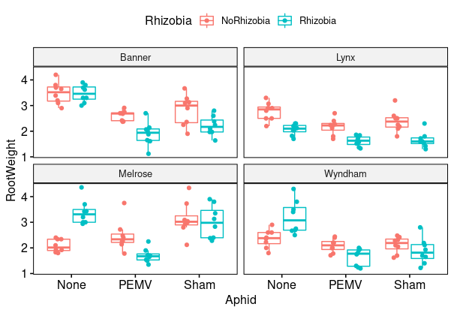
Fig. 2. Effects of soil rhizobia on pea shoot weight when faced with no stressors, aphids, or aphids and virus
Fig. 3. Effects of soil rhizobia on pea root weight when faced with no stressors, aphids, or aphids and virus

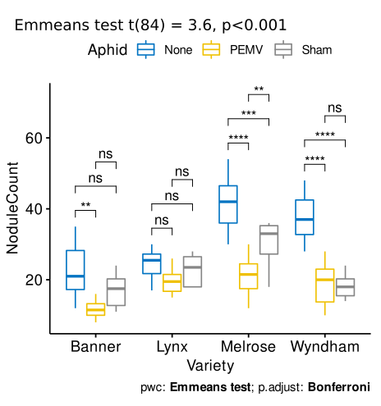
While effects of soil rhizobia in this experiment were variable, with lower root weight but greater shoot weight and plant survival, we saw strong impacts of aphids and PEMV on plant mutualisms with rhizobia (Fig. 4). We also found that both aphids and PEMV significantly reduced nodule count across all the cultivars tested (Fig. 4). These effects were particularly strong on the Melrose and Wyndham cultivars, suggesting potential limits on mutualisms with rhizobia in areas with aphid and PEMV. This experiment also showed that Lynx was a cultivar relatively unimpacted by PEMV and may be a cultivar for high risk aphid and virus areas.
Fig. 4. Effects of aphids and PEMV on nodule growth for four pea cultivars. PEMV had strongly negative effects for all but one cultivar, and aphids also had strong impacts.
We expanded on our first experiment by conducting a broader examination with 6 winter pea cultivars in a 6 × 3 × 2 factorial design (3 aphid treatments and 2 rhizobia treatments). As before, peas were grown in the presence or absence of rhizobia for 2 wk before aphid treatments were applied for 48 h. All plants were then grown for 7 days before data were collected. This experiment showed considerable variation in the tolerance of the six cultivars to the PEMV cultivar (Fig. 5). Cultivars Wyndham, MiCa, and Melrose were fairly susceptible to the PEMV pathogen, but cultivars Dint, Klondike, and Lynx were fairly tolerant (Fig. 5). While the tolerant cultivars were relatively unaffected by rhizobia, we found that rhizobia significantly reduced susceptibility of Melrose and MiCa (Fig. 5). Unlike the first experiment, we found that soil rhizobia did not negatively impact root weight, but did increase shoot weight (Figs. 6, 7).

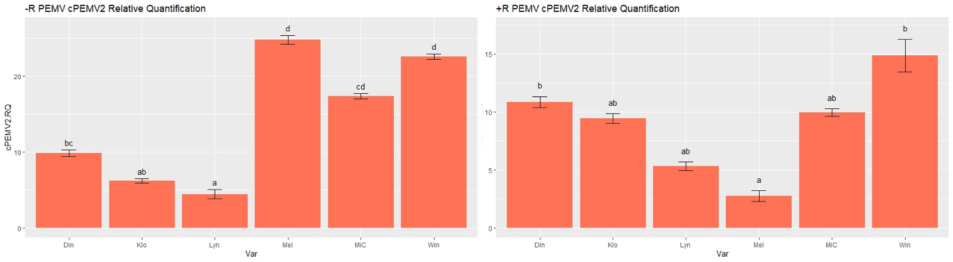
Fig. 5. Relative titer of PEMV across six winter pea cultivars without (left panel) or with (right panel) rhizobia
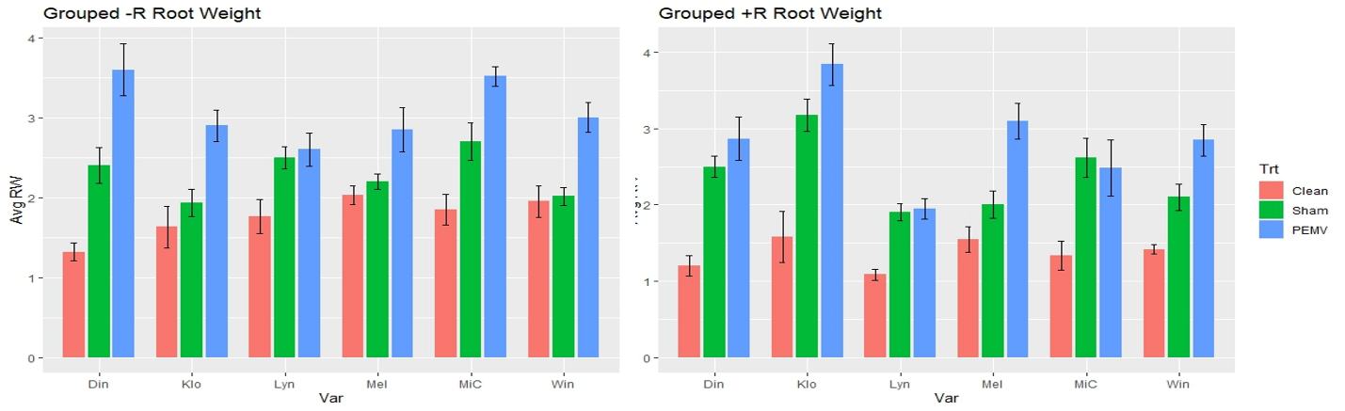
Fig. 6. Average root weight for 6 winter pea cultivars grown with or without rhizobia and various stress treatments
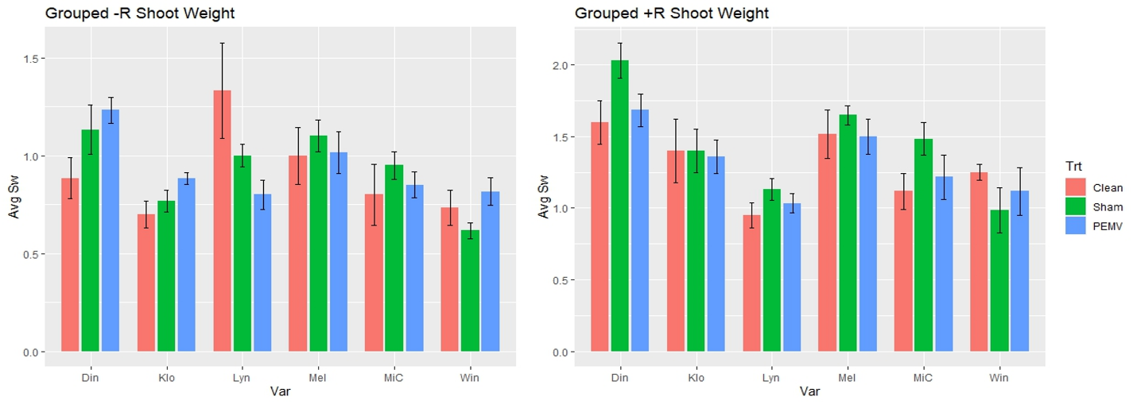
Fig. 7. Average shoot weight for 6 winter pea cultivars grown with or without rhizobia and various stress treatments
From a molecular perspective, our experiments showed that biotic stressors such as aphids and PEMV inhibited defensive responses of peas and lowered fatty acid levels (Figs. 8, 9). In our experiments we assessed levels of four growth hormones involved in defense: (a) jasmonic acid, (b) salicylic acid, (c) indole acetic acid, and (d) abscisic acid. We found that jasmonic acid and salicylic acid were impacted by PEMV, which inhibited production of these defense pathways in most cultivars. We did not find evidence of rhizobia effects on indole acetic acid or abscisic acid, indicating they are less directly involved in aphid-virus-plant interactions (Fig. 8). We also found that hormone levels varied by variety, which may underlie variation in tolerance to PEMV. We are continuing to assess the molecular data from the second experiment, although the first experiment clearly show impacts of rhizobia and stressors on plant defense. Future investigations will allow us to better understand the mechanisms that mediate tolerance to aphids and PEMV across winter pea varieties that are grown with or without rhizobia inoculants.

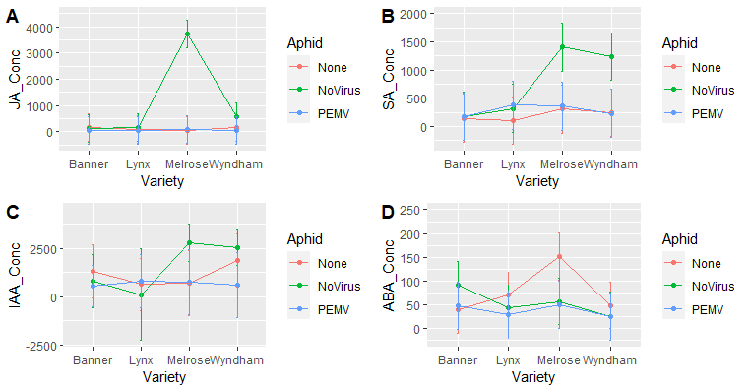
Fig. 8. Relative concentrations of (A) jasmonic acid, (B) salicylic acid, (C) indole acetic acid, and (D) abscisic acid across three winter pea varieties and one spring pea variety with three aphid treatments.

Fig. 9. Levels of saturated and unsaturated fatty acids in each winter pea variety exposed to various treatments.
Outreach & Education Activities:

In 2022 and 2023 PI Crowder delivered presentations on PEMV, aphids, and integrated pest management at meetings organized by the USA Dry Pea and Lentil Council. Co-PI Basu and graduate student Baerlocher also presented results at the 2022 and 2023 meetings of the Pacific Branch of the Entomological Society of America. Working with cooperator McGee, in both 2022 and 2022 pest and water management in winter peas were the focus of field days and diagnostic clinics in Pullman, Lind, and Central Ferry. We also conducted outreach at locations containing breeding nurseries and yield trials. At these events, growers and other stakeholders were able to see advanced winter pea cultivars in development and learn about the key differences in growth habitats and agronomic traits while seeing sustainable agricultural practices in action.
Our project also involved training of undergraduate students Anna Rodgers and Arianna Espinosa. Anna worked for our laboratory throughout 2022 and 2023 before graduating with a degree in neurobiology, and she contributed considerably to all of our molecular work. Arianna is currently working under the mentorship of graduate student Baerlocher and will present her results at the 2024 SURCA about effects of rhizobia on winter pea cultivars. PhD student Chase Baerlocher also become interested in using microscopy to assess how winter pea plant nodules respond to biotic stress. As a result of his work in classes, he is now a teaching assistant in the graduate course in microscopy at WSU and uses his research from this project as a model for other graduate students; this project will also spur research in root microscopy.

Impacts:

Short-Term (1-2 years): (1) Determined which cultivar(s) of winter pea exhibit enhanced growth, productivity, and tolerance to pests (pea aphids and PEMV); (2) assess how beneficial soil rhizobia affect tolerance of winter pea cultivars to biotic stress across a range of conditions; (3) provide a detailed analysis of rhizobia-induced molecular and biochemical mechanisms that may promote tolerance to stress in different winter pea cultivars; (4) recruit a PhD student and use the project as the basis of their dissertation project; (5) publish results from the project; (6) leverage data from the BioAg project to develop and submit federal grant proposals; and (7) train WSU undergraduate students in entomology, ecology, and molecular biology.

Intermediate-term (3-5 years): (1) Leverage data from the project along with ongoing research on aphids to improve our predictive ability for outbreaks across dryland regions of Washington and identify areas most at risk; (2) reduce use of prophylactic insecticide sprays in legumes by increasing our systems-level understanding of effects of beneficial soil microbes (e.g., rhizobia) in promoting legume health, productivity, and resistance to pests and abiotic stress; (4) expand research in emerging pests in pea fields and the effects of complex interactions of multiple pests; (5) support the commercialization of winter pea cultivars, and provide information to growers on which growers may be best suited for which environmental conditions; (6) broadly increase grower knowledge of strategies to manage water stress, aphids, and pathogens.

Long-term (5+ years): (1) Broad integration of winter pea cultivars across dryland ecosystems of Washington; (2) increased benefits of winter pea as a rotational crop; (3) greater sustainability and profitability of transformative specialty crops like winter pea; and (4) long-term reductions in pesticide application throughout Washington without sacrificing aphid and virus control.

Additional funding applied for/secured:

We applied for a grant from the USDA Pulse Crop Health Initiative in 2023 and it was highly rated but not funded. Baerlocher applied for a NSF Graduate Research Fellowship in 2024, and that proposal is pending. Crowder and Basu also applied to a grant from the USDA Pest and Beneficial Species program in 2023, and that grant is pending.

Graduate students funded:

Chase Baerlocher, Molecular Plant Sciences

Recommendations for future research:

Our research strongly suggests that rhizobia have an impact on winter pea cultivars, and that biotic stressors such as aphids and PEMV can limit plant-rhizobia synthesis. We are currently working with Dr. Stephanie Porter of WSU Vancouver to expand on this research in several ways. First, we need to better understand how variation in plant-rhizobia synthesis affects the tolerance of winter pea to biotic and abiotic stress. Dr. Porter’s lab maintains a variety of rhizobia strains that differ in their ability to form mutualisms with plants, and we hope to further assess how different strains may variably affect unique winter pea cultivars. Second, we need to better understand how rhizobia affect winter pea across variable environments. Winter peas are grown in extremely dry areas such as Lind, and higher rainfall areas like Pullman. The benefits or tradeoffs of different rhizobia strains may differ by environment. We hope to build on work reported here by conducting field experiments in more environments.

